“Online Food Delivery Platform: Multi-Restaurant Ordering & Unified Checkout”
A Project Report Submitted in the partial fulfillment of the requirements for the award of the degree of

BACHELOR OF TECHNOLOGY
In

DEPARTMENT OF COMPUTER SCIENCE ENGINNERING
&
DEPARTMENT OF COMPUTER SCIENCE AND INFORMATION TECHNOLOGY
By

M.V.L.SAMHITA 2520030509
G.SAHASRA 2520030108
T.TEJASWINI 2520030510

Under the Esteemed Guidance of

Dr Y. Prashanthi
Assistant Professor
Department of Computer Science and Engineering




K L (Deemed to be) University DEPARTMENT OF COMPUTER SCIENCE ENGINEERING
&

DEPARTMENT OF COMPUTER SCIENCE AND INFORMATION TECHNOL

Declaration

The Project Report entitled “Online Food Delivery Platform: Multi-Restaurant Ordering & Unified Checkout” is a record of Bonafide work of M.V.L SAMHITA – 2520030509, G.SAHASRA – 2520030108, T.TEJASWINI - 2520030510 submitted in partial fulfillment for the award of B. Tech in Computer Science and Engineering (or) Computer Science and Information Technology to the K L University. The results embodied in this report have not been copied from any other departments/University/Institute.

M.V.L SAMHITA - 2520030509

G. SAHASRA - 2520030108

T.TEJASWINI– 2520030510

K L (Deemed to be) University

DEPARTMENT OF COMPUTER SCIENCE ENGINEERING

&

DEPARTMENT OF COMPUTER SCIENCE AND INFORMATION TECHNOLOGY

CERTIFICATE

This is certify that the mini project based report entitled “Online Food Delivery Platform: Multi-Restaurant Ordering & Unified Checkouts” is a bonafide work done and submitted by of M.V.L SAMHITA – 2520030509, G.SAHASRA – 2520030108, T.TEJASWINI - 2520030510 in partial fulfillment of the requirements for the award of the degree of BACHELOR OF TECHNOLOGY in Department of Computer Science Engineering, K L (Deemed to be University), during the academic year 2025-2026.

Signature of the Guide

Signature of the Course Coordinator Signature of the HOD

ACKNOWLEDGEMENT
The success in this project would not have been possible but for the timely help and guidance rendered by many people. Our wish to express my sincere thanks to all those who has assisted us in one way or the other for the completion of my project.

Our greatest appreciation to my Course Coordinator Ramatenki Sateesh Kumar my guide Ramatenki Sateesh Kumar, Department of Computer Science which cannot be expressed in words for his/her tremendous support, encouragement and guidance for this project.

We express our gratitude to Dr. P Venkateshwara Roa (Head of the Department for Computer Science Engineering for providing us with adequate facilities, ways and means by which we are able to complete this project-based Lab.

We thank all the members of teaching and non-teaching staff members, and also who have assisted me directly or indirectly for successful completion of this project. Finally, I sincerely thank my parents, friends and classmates for their kind help and cooperation during my work.

M.V.L SAMHITA - 2520030509

G. SAHASRA - 2520030108

T.TEJASWINI– 2520030510

Abstract

The Online Food Delivery Platform: Multi-Restaurant Ordering & Unified Checkout is a web-based food ordering and delivery management system designed to simplify the process of ordering food from multiple restaurants through a single platform.
Traditional food delivery applications generally require customers to place separate orders when purchasing food from different restaurants. This can result in multiple checkout processes, separate payments, independent order tracking, and difficulty in managing different deliveries. The proposed system addresses this problem by introducing a unified multi-restaurant ordering mechanism.
The platform allows customers to browse restaurants, search for food items, view menus, check ingredient and allergen information, apply dietary preferences, add items from different restaurants into one unified cart, and complete a single checkout process. Internally, the system creates a master order and divides it into restaurant-specific orders so that each restaurant can independently process its respective items.
The system consists of four major roles: Customer, Restaurant, Delivery Partner, and Admin. Customers can browse and order food, restaurants can manage menus and process orders, delivery partners can manage assigned deliveries and update delivery status, and administrators can monitor users, restaurants, delivery partners, orders, commissions, and offers.
The proposed technology stack consists of React.js for the frontend, Node.js and Express.js for backend services, MySQL for relational database management, Socket.io for real-time communication, Google Maps API for location-related services, and payment integration for online transactions.
The system aims to provide a convenient, centralized, scalable, and efficient food ordering experience while simplifying restaurant-side order processing and delivery management.

Index

S.  No. | Chapters | Topics | Page.no
 |  | Acknowledgement
 |  | Abstract
1 | Introduction | - Background of the project  - Problem statement  1.3Objective(s)  1.4Scope of the Project  1.5 Significance of the project  1.6 Target Users / Audience | 5-15
2 | System Requirements | 2.1 Functional Requirements  2.2 Non-Functional Requirements  2.3 Hardware Requirements  2.4 Software Requirements  2.5 User Requirements | 16-21
3 | Technology Stack | 3.1 Frontend Technologies  3.2 Backend Technologies  3.3 Database Technologies  3.4 APIs and External Services  3.5 Development Tools | 22-32
4 | System Architecture | 4.1 High-Level Architecture  4.2 Frontend Layer  4.3 Backend Layer  4.4 Database Layer  4.5 Real-Time Communication  4.6 Deployment Architecture | 33-36
5 | Design | 5.1 Use Case Design  5.2 ER Diagram  5.3 Database Schema  5.4 Data Flow  5.5 Order Processing Design | 37
6 | Implementation | 6.1 Module-Wise Implementation  6.2 Front-End Logic  6.3 Backend Implementation  6.4 API Integration  6.5 Authentication and Authorization  6.6 Database Implementation | 38-47
7 | Features | - Main Features  7.2 Working of Each Feature | 48-55
8 | Testing | - API Testing  8.2 Integration Testing  8.3 Testing Tools  8.4 Test Cases and Results | 56-64
9 | Deployment | - Deployment Steps  9.2 Environment Configuration  9.3 Frontend and Backend Hosting | 65-73
10 | Challenges & Limitations | 10.1 Issues Faced  10.2 Solutions Applied  10.3 Current Limitations | 74-82
11 | Future Enhancements | - Future Enhancements | 83-88
12 | Conclusion | Conclusion | 89-97
13 | References | - Books, tutorials, APIs, documentation sites used | 98-99

14 | Appendices | - Screenshots of the app  - Sample code snippets  - Installation/setup instructions  - User manual or guide  -Geo Tag photos with guide  -Review forms with guide signatures | 100-105

CHAPTER -1 INTRODUCTION

1.1 Background of the Project
Online food ordering has become an important application of modern web technology. Digital platforms have changed the way customers discover restaurants, examine menus, select food items, place orders, make payments, and receive deliveries. Instead of depending completely on physical visits, telephone calls, or manual ordering, customers can now interact with restaurants through digital interfaces. A food delivery platform therefore combines several areas of software engineering, including user-interface development, database management, transaction processing, authentication, order management, delivery coordination, and real-time communication.
Although online food ordering provides significant convenience, the ordering process becomes more complicated when a customer wants food items from different restaurants. In a conventional restaurant-centered ordering model, a cart is generally associated with one restaurant. If a customer wants to purchase food from another restaurant, the customer may need to start another ordering process. This can result in multiple carts, multiple checkout processes, separate order identifiers, separate payment transactions, and separate tracking information.
The proposed Online Food Delivery Platform: Multi-Restaurant Ordering & Unified Checkout is designed around a different ordering architecture. The main objective is to provide a common environment in which a customer can discover multiple restaurants, browse their menus, select food items from different restaurants, and maintain those selections within one unified cart. The customer can then proceed through a single checkout process rather than treating every restaurant selection as an entirely separate customer transaction.
The central concept of the project is the master-order mechanism. A customer may select food items from several restaurants, but the system does not require the restaurants to process the entire customer transaction as one undivided order. Instead, the complete customer transaction is represented through a master order. The system can then divide the master order into restaurant-specific orders. Each restaurant receives and processes only the items belonging to that restaurant.
This approach creates a distinction between the customer view and the restaurant processing view. From the customer's perspective, the order is unified. From the restaurant's perspective, only the restaurant's own portion is visible for processing. This separation is an important aspect of the proposed system because different restaurants may have different menus, preparation times, order statuses, and operational requirements.
The project is therefore not limited to creating a basic online food ordering interface. It focuses on designing a complete multi-role system in which customers, restaurants, delivery partners, and administrators interact with the same platform while having different responsibilities and access requirements.
The customer module forms the primary user-facing component of the system. Customers can browse and search restaurants, view menus, select food items, add items from different restaurants to the unified cart, complete checkout, and track their orders. The system also includes ratings and reviews so that customers can provide feedback after completing an order.
Another important aspect of the customer module is the inclusion of meal-time recommendations. Food preferences can change depending on the time of the day. Breakfast, lunch, snacks, and dinner may involve different types of food choices. The proposed system therefore includes meal-time-based food recommendations as part of the platform's functionality.
The platform also addresses the need for better food information. Food items can contain ingredient and allergen information so that customers can make more informed selections. The project also includes dietary preference filters. According to the project proposal, these filters can include preferences such as vegetarian, vegan, spicy, and non-spicy food choices. These features are intended to improve the customer's ability to identify suitable food items before placing an order. bc2ae554-7a76-4069-a0f9-2e6afac…
The restaurant module is responsible for restaurant-level operations. Restaurants can manage their menus, maintain ingredient and allergen information, receive restaurant-specific orders, accept and process orders, update order statuses, and manage offers and discounts. The restaurant therefore interacts with only the relevant portion of a customer's master order.
For example, consider a customer who selects two food items from Restaurant A and three food items from Restaurant B. From the customer's perspective, all five items can be maintained within one unified cart. After checkout, the system can create one master order representing the complete transaction. The system then creates a restaurant-specific order for Restaurant A containing the two relevant items and another restaurant-specific order for Restaurant B containing the three relevant items.
The following conceptual flow represents this mechanism:
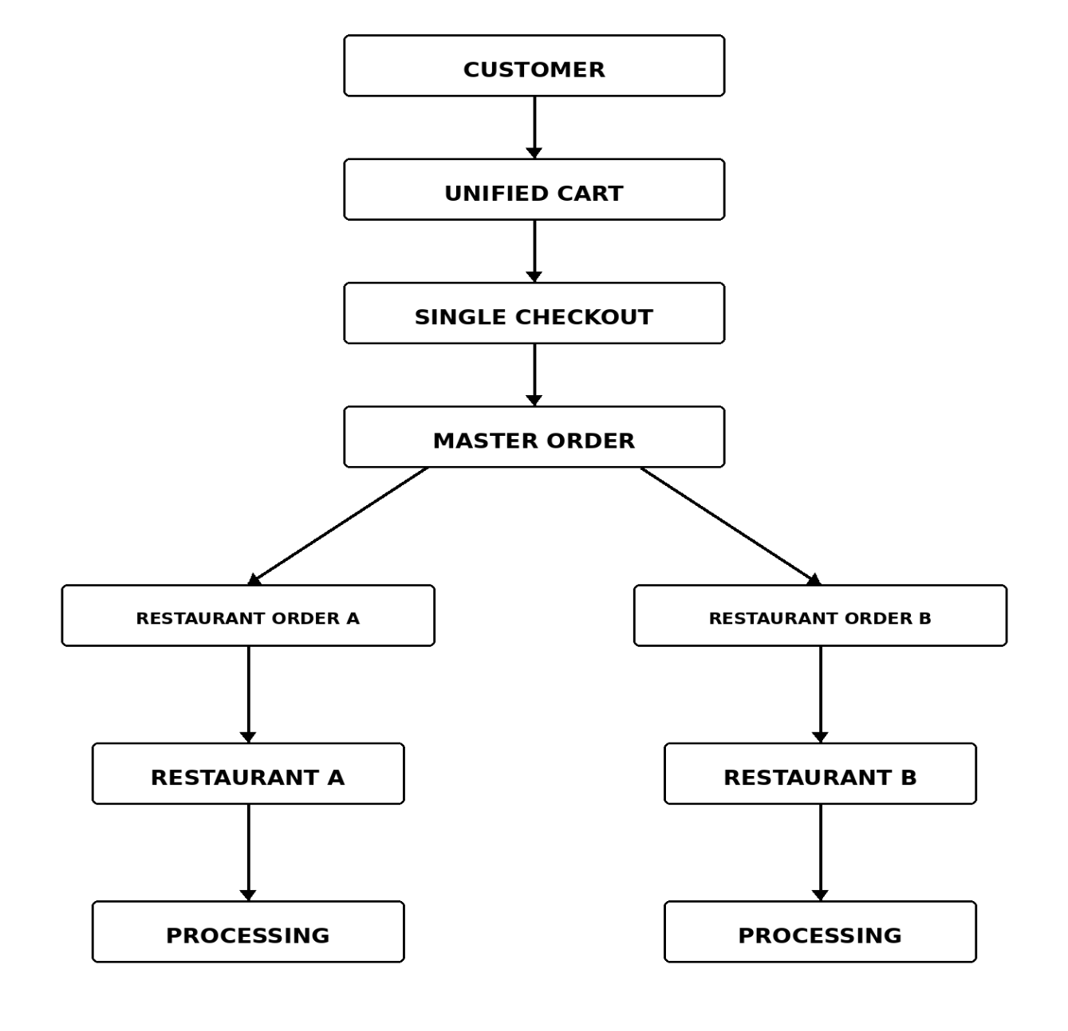This design allows restaurants to independently process their orders while preserving the customer's unified experience.
The delivery partner module forms the next important component of the platform. Delivery partners can view assigned deliveries, accept delivery requests, manage pickup and delivery activities, update delivery status, and support live location tracking. Delivery operations therefore form a bridge between restaurant processing and final customer delivery.
The proposed system also includes an administrator module. The administrator has a centralized role in managing customers, restaurants, delivery partners, orders, commissions, offers, and discounts. This provides a platform-level management layer through which overall system activity can be monitored.
The four major roles can therefore be summarized as follows:
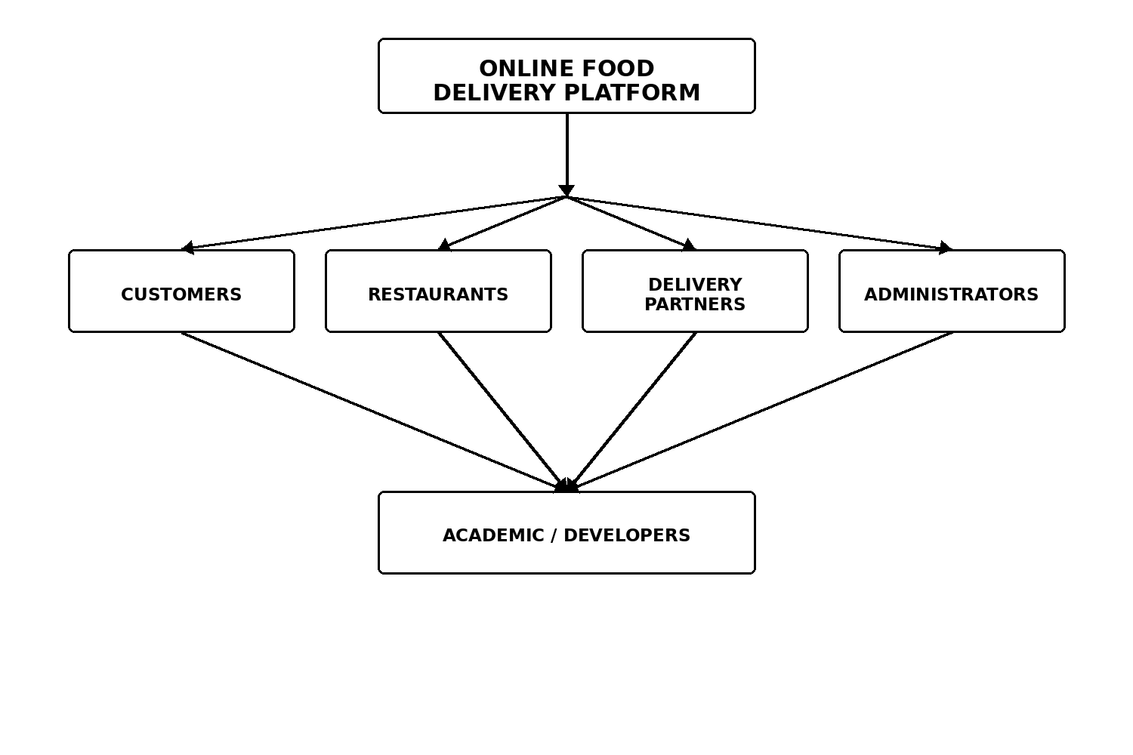
The technical architecture of the proposed system follows a full-stack approach. React.js is used for the frontend user interface. Node.js is planned as the backend runtime, while Express.js is used as the REST API framework. MySQL is used as the relational database. Socket.io is included to support real-time order and delivery updates. Google Maps API is intended for location and mapping functionality, while the project proposal identifies x402 Aragen as the payment technology. bc2ae554-7a76-4069-a0f9-2e6afac…
The architecture can therefore be represented as:
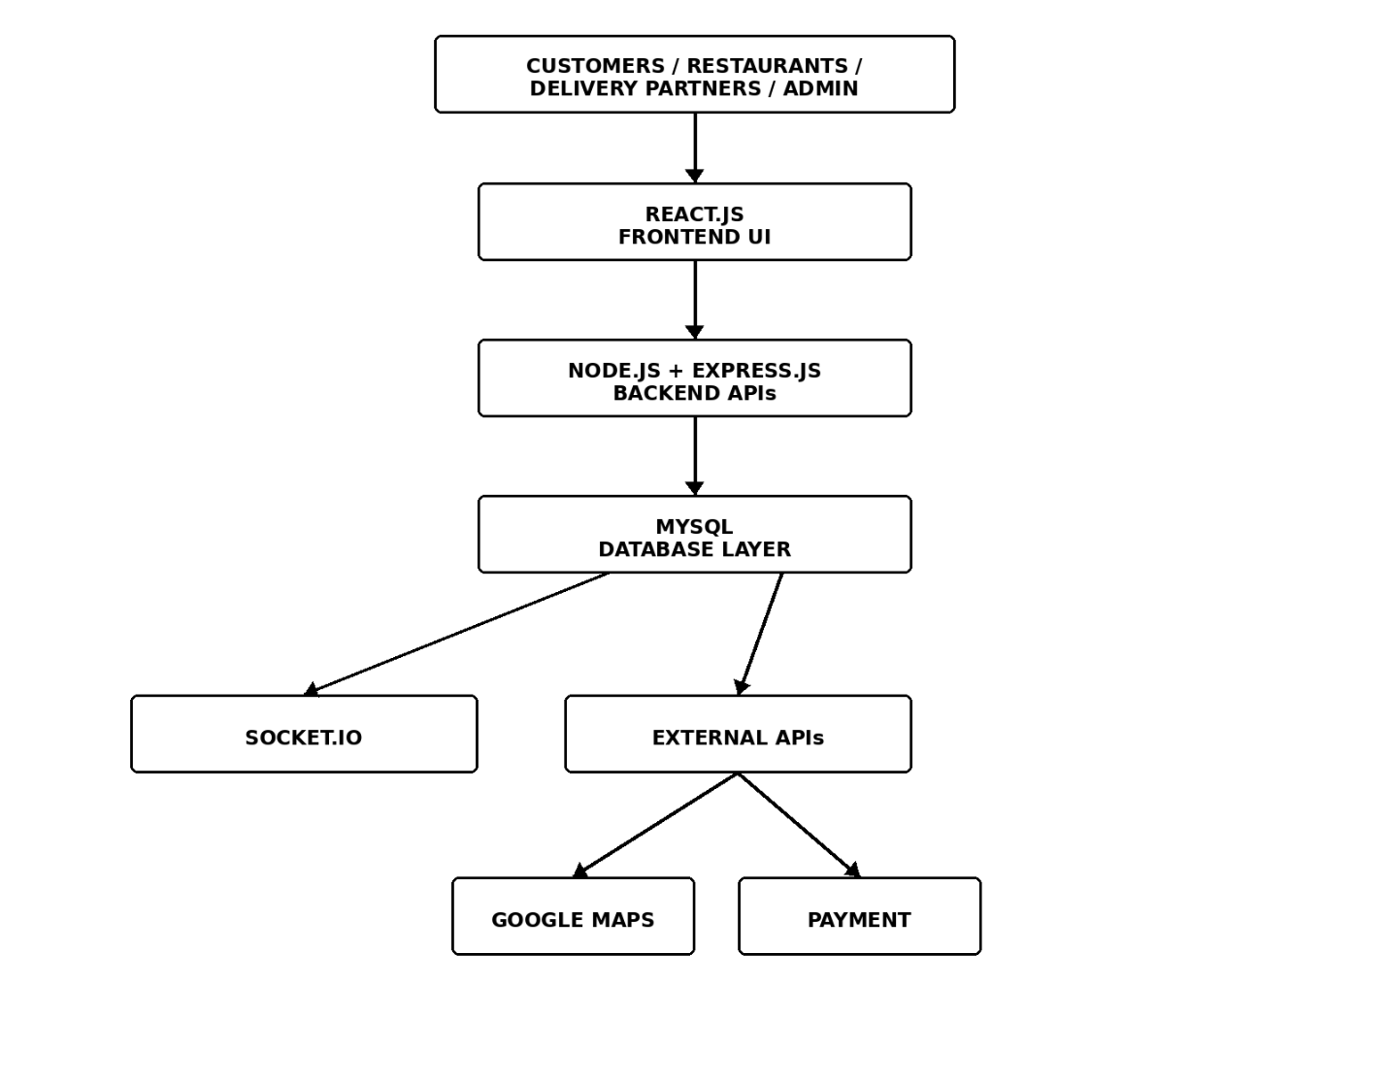
The frontend prototype currently demonstrates the major user interface and application flows. The complete backend and database integration represent the target full-stack architecture of the project. This distinction is important because the project documentation describes the intended complete system while the present prototype represents the frontend stage of development.
The project is therefore designed as a progressive full-stack system. The frontend establishes the user experience, navigation, pages, forms, dashboards, and ordering flow. The backend can subsequently provide API-based communication and business logic. The database provides persistent storage for users, restaurants, menu items, orders, payments, deliveries, reviews, and related records.
The database component is particularly important because the master-order mechanism requires relationships between multiple entities. A customer can have multiple master orders. A master order can contain multiple restaurant-specific orders. A restaurant can have multiple menu items and multiple restaurant-specific orders. Restaurant orders can contain multiple order items. Payments and deliveries can be associated with the relevant order records. Reviews can connect customers with restaurants or completed transactions.
The relational database therefore provides the foundation for maintaining consistency across the platform. Instead of storing all information in one large undifferentiated structure, the system can organize information into related entities. This approach supports easier retrieval, modification, validation, and maintenance of data.
The proposed platform also emphasizes real-time communication. Order processing is dynamic because restaurant status can change as an order moves from acceptance to preparation and readiness. Delivery status can also change as a delivery partner accepts a task, picks up food, and completes delivery. Socket.io is therefore included in the proposed architecture to support real-time order and delivery updates. bc2ae554-7a76-4069-a0f9-2e6afac…
The project additionally considers location-based delivery functionality. Google Maps API is included in the proposed technology stack for location services and delivery tracking. This can support future functionality related to delivery locations, routes, and live tracking.
Payment processing is another important part of the unified checkout model. The project proposal identifies x402 Aragen as the payment technology. The unified payment concept allows the customer to complete the combined transaction through one checkout process while the backend maintains the relationship between the overall transaction and its restaurant-specific orders.
The overall background of the project can therefore be understood through three major ideas. First, the system provides a unified customer experience. Second, it maintains independent restaurant-level processing. Third, it connects all operational components through a structured technical architecture.
The proposed system is particularly relevant from a database and system-design perspective. The major challenge is not simply displaying restaurant menus. The more important challenge is maintaining the relationship between a single customer transaction and multiple restaurant-specific processing units. The master-order mechanism provides the conceptual solution to this challenge.
The project also demonstrates the importance of designing software around real-world roles. A customer does not require access to restaurant management functions. A restaurant should not be able to modify unrelated restaurants' orders. A delivery partner requires access to delivery tasks rather than administrative configuration. An administrator requires broader monitoring and management capabilities. Role-based dashboards therefore provide a logical structure for the application.
From an academic perspective, the project combines multiple concepts studied in computer science and software development. Frontend development is represented through React.js. Backend development is represented through Node.js and Express.js. Database design is represented through MySQL and relational entities. API communication connects frontend and backend services. Real-time communication is represented through Socket.io. External services extend the platform through mapping and payment functionality.
The project also provides an opportunity to study how a real-world business process can be converted into a software system. Food ordering involves customers, restaurants, payments, food preparation, delivery, and feedback. Each process has different requirements, but the proposed platform brings them together into a single system.
The overall purpose of the platform is therefore to reduce fragmentation in multi-restaurant ordering. Instead of forcing the customer to manage independent restaurant transactions, the system provides one unified customer-level experience while preserving restaurant-level independence.
This combination of unified customer experience and independent operational processing is the core idea of the project.
1.2 Problem Statement
Existing online food delivery systems commonly organize ordering around individual restaurants. A customer's cart is generally associated with a particular restaurant, and ordering from another restaurant may require another ordering process. When a customer wants food from multiple restaurants, this can result in repeated steps.
The project presentation identifies multiple issues associated with this type of ordering model. These include multiple checkouts, separate order tracking, fragmented multi-restaurant ordering, variable delivery times, limited ordering flexibility, lack of meal-time recommendations, and limited allergy information. DBSE_PROJECT_PPT (1)(6)
Multiple checkout processes increase the effort required from the customer. If food items are selected from different restaurants, the customer may have to complete separate transactions instead of confirming the entire selection through one unified process.
Separate order tracking creates another difficulty. When different restaurant orders have different order identifiers and statuses, the customer must monitor each order independently. This can make it difficult to obtain one clear view of the overall ordering process.
Fragmented multi-restaurant ordering is the central problem addressed by this project. The proposed platform aims to allow food items from different restaurants to exist within one unified cart and one checkout process.
Restaurants also require independent processing. If a master order contains food from several restaurants, Restaurant A should not need to process Restaurant B's food items. Therefore, the system must preserve restaurant-level separation even though the customer experiences one unified order.
The system must consequently solve two apparently different requirements at the same time. It must provide unification at the customer level and separation at the restaurant level.
The problem can be represented as:
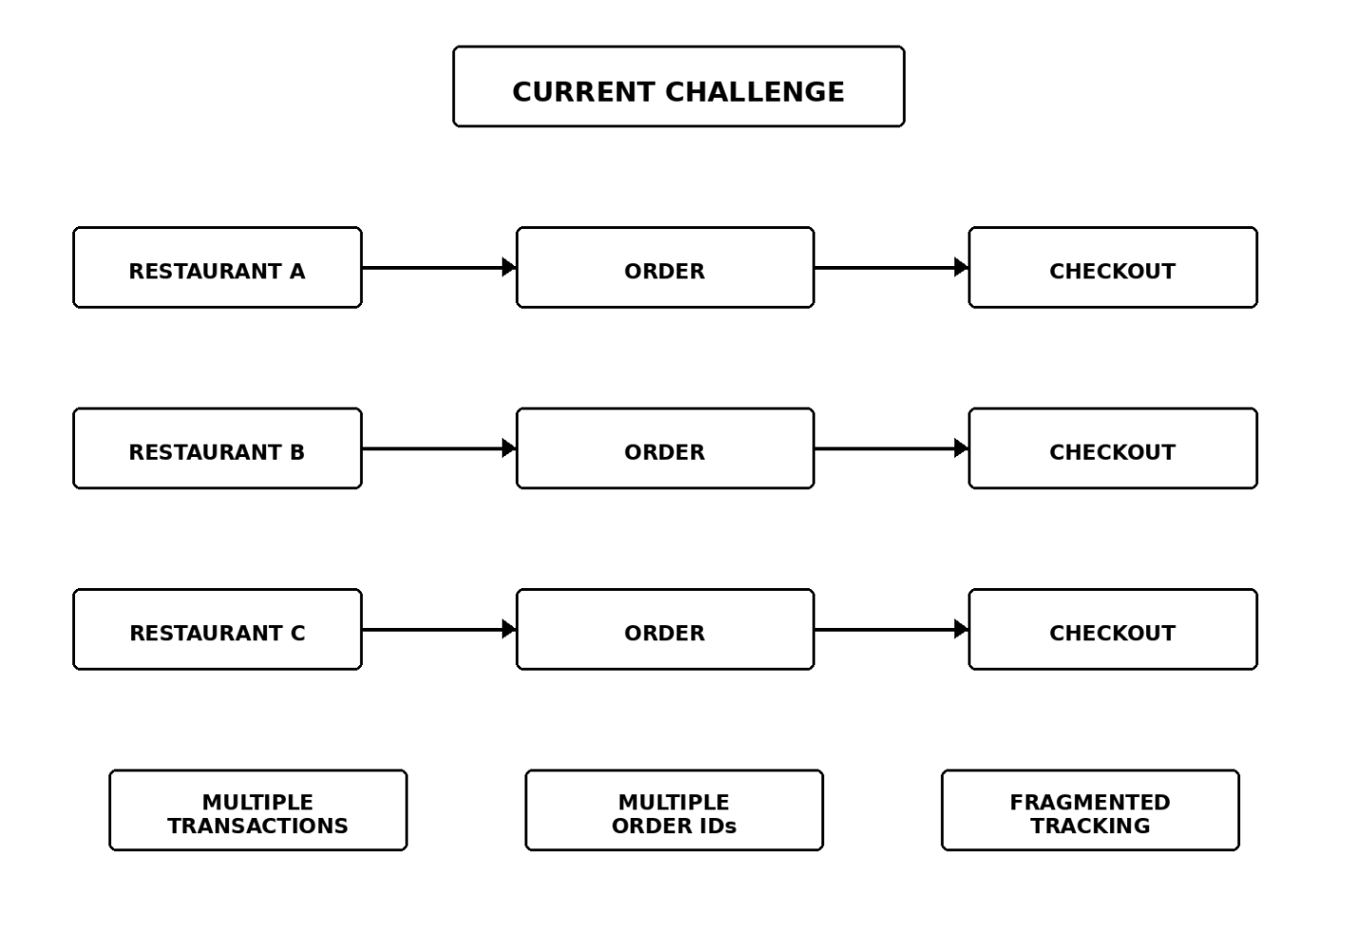
Therefore, the problem addressed by the project is the design of a unified multi-restaurant food delivery platform that allows customers to combine food selections from different restaurants into one ordering session while preserving independent restaurant-level order processing.
The system must maintain a common cart and checkout mechanism, generate a master order, split the master order into restaurant-specific orders, allow restaurants to process their respective orders, support delivery assignment, provide order tracking, and provide centralized administrative monitoring.
The project also addresses the information gap faced by customers when selecting food. Meal-time recommendations can assist customers in discovering suitable options for breakfast, lunch, snacks, and dinner. Ingredient and allergen information can provide additional information before selection. Dietary preference filters can help customers narrow down food options according to their requirements.
The problem therefore includes both an ordering problem and an information problem. The ordering problem concerns fragmented multi-restaurant transactions, while the information problem concerns limited availability of meal-time, ingredient, allergen, and dietary information.
The project aims to address these problems through a single platform rather than separate applications or disconnected workflows.
1.3 Scope of the Project
The scope of the Online Food Delivery Platform covers the design and development of a multi-role web application capable of supporting customers, restaurants, delivery partners, and administrators.
The customer-side scope includes restaurant discovery, restaurant searching, menu browsing, food selection, unified cart management, unified checkout, payment, order tracking, ratings, reviews, meal-time recommendations, ingredient information, allergen information, and dietary preference filters.
Customers can interact with restaurants through a common interface. They can search for restaurants and inspect available food items before making selections. The multi-restaurant cart allows food items from different restaurants to be maintained within one ordering session.
The restaurant-side scope includes menu management, ingredient and allergen management, restaurant-specific order handling, order acceptance, order processing, status updates, and offers or discounts.
The restaurant receives only the restaurant-specific portion generated from the master order. This allows the restaurant to operate independently without needing to process food items belonging to another restaurant.
The delivery partner scope includes viewing assigned deliveries, accepting delivery requests, managing pickup and delivery operations, updating delivery status, and supporting live location tracking.
The administrator scope includes management of customers, restaurants, delivery partners, orders, commissions, offers, and discounts.
The technical scope includes React.js for frontend development, Node.js and Express.js for backend services, MySQL for relational database management, Socket.io for real-time communication, Google Maps API for location functionality, and x402 Aragen for the proposed payment functionality.
The project also provides scope for future expansion. The platform can be extended to support more restaurants, delivery partners, cities, payment methods, recommendation models, analytics, loyalty features, notifications, and other platform-level capabilities.
The scope can therefore be divided into four major functional areas:
CUSTOMER
- Restaurant browsing
- Menu browsing
- Unified cart
- Unified checkout
- Order tracking
- Reviews
- Recommendations
- Dietary filters
- Allergen information

RESTAURANT
- Menu management
- Ingredient management
- Allergen management
- Order processing
- Status updates
- Offers and discounts

DELIVERY PARTNER
- Assigned deliveries
- Delivery acceptance
- Pickup
- Delivery
- Status updates
- Location tracking

ADMIN
- User management
- Restaurant management
- Delivery partner management
- Order monitoring
- Commission management
- Offers and discounts
The scope does not imply that every proposed external integration is already fully implemented in the current frontend prototype. The current prototype demonstrates the main frontend flows, while the complete backend, database, real-time, mapping, and payment integrations form the target system architecture.
1.4 Objectives of the Project
The primary objective is to develop a unified online food ordering platform that connects customers with multiple restaurants through a common ordering environment.
The project objectives include:
- To develop a platform that allows customers to browse and order from multiple restaurants in a single session.
- To provide a unified cart capable of containing food items selected from different restaurants.
- To provide a single checkout and payment workflow for the combined customer transaction.
- To implement a master-order mechanism that represents the complete customer transaction.
- To automatically divide the master order into restaurant-specific orders.
- To allow restaurants to independently accept, process, and update their respective orders.
- To provide restaurants with dedicated functionality for menu management.
- To allow restaurants to maintain ingredient and allergen information.
- To enable delivery partners to view and accept assigned deliveries.
- To provide delivery partners with mechanisms for updating pickup and delivery status.
- To provide customers with consolidated order tracking across restaurant-specific orders.
- To provide meal-time recommendations for breakfast, lunch, snacks, and dinner.
- To provide ingredient and allergen information to support informed food selection.
- To provide dietary preference filters such as vegetarian, vegan, spicy, and non-spicy options.
- To provide ratings and reviews for customer feedback.
- To provide administrators with centralized control over customers, restaurants, delivery partners, orders, commissions, and offers.
- To maintain users, restaurants, menu items, orders, and related records through a structured relational database.
- To support real-time order and delivery updates through the proposed Socket.io integration.
- To provide location-related functionality through the proposed Google Maps integration.
- To provide a scalable architecture that can be extended with additional restaurants, cities, payment methods, recommendations, analytics, and loyalty features.
These objectives collectively define the expected functionality and technical direction of the project. They also establish a connection between the project's problem statement and its proposed solution.
1.5 Importance of the Application
The application is important because it addresses the specific difficulty of managing food selections from multiple restaurants through separate ordering processes.
For customers, the major advantage is the unified ordering experience. A customer can browse multiple restaurants, select food items, place them into one cart, and proceed through a common checkout process. This reduces the number of repeated actions required during multi-restaurant ordering.
The master-order mechanism is important because it allows the system to combine customer-level convenience with restaurant-level independence. The customer sees one overall transaction, while each restaurant receives only the relevant portion of that transaction.
For restaurants, the platform provides a structured mechanism for receiving orders. Restaurant-specific order records prevent a restaurant from being required to process unrelated items. Restaurants can manage their menus, process orders, update statuses, and manage offers.
For delivery partners, the platform provides organized delivery assignments and status management. This creates a structured connection between restaurant order processing and customer delivery.
For administrators, the system provides centralized visibility over platform operations. Instead of managing separate systems for different participants, the administrator can manage users, restaurants, delivery partners, orders, commissions, and offers through one platform.
The application is also important from a database-design perspective. The master-order mechanism requires multiple related entities to work together. The database must preserve the relationship between the customer, master order, restaurant-specific orders, order items, restaurants, payments, and deliveries.
The project is also significant academically because it combines frontend, backend, database, API, and real-time communication concepts in one system.
1.6 Target Users / Audience
The proposed platform is designed for four major operational user groups: customers, restaurants, delivery partners, and administrators.
Customers are the primary users of the ordering interface. They can search restaurants, browse menus, select food items, manage the unified cart, complete checkout, track orders, and provide ratings and reviews.
Restaurants use the platform to manage their food offerings and process incoming restaurant-specific orders. They can manage menus, ingredients, allergen information, order status, and promotional offers.
Delivery partners use the system to manage assigned delivery tasks. They can accept delivery requests, manage pickup and delivery operations, update delivery status, and support location-related delivery functionality.
Administrators manage the overall platform. They can manage customers, restaurants, delivery partners, orders, commissions, offers, and discounts.
The project also has an academic and development audience. Students and developers can study the project as an example of a multi-role web application involving relational database design, master-order processing, REST APIs, role-based access, and real-time communication.
The target audience can therefore be summarized as:
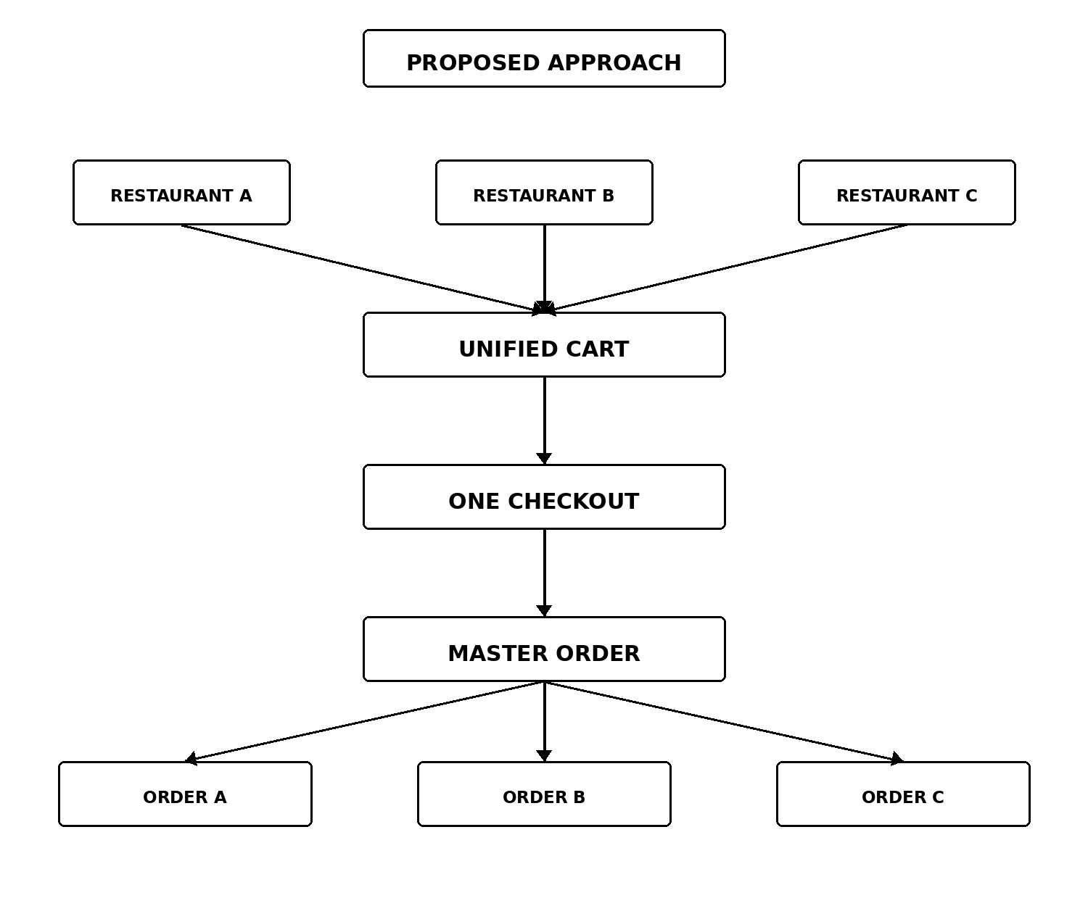

CHAPTER 2 – SYSTEM REQUIREMENTS
The system requirements define the resources, capabilities, functions, and quality characteristics required for the development of the Online Food Delivery Platform: Multi-Restaurant Ordering & Unified Checkout. The proposed platform is a multi-role web application designed to connect customers, restaurants, delivery partners, and administrators through a common digital environment.
The system requirements are important because the application contains several interconnected processes. A customer should be able to browse restaurants and select food items from multiple restaurants. Those selections should be maintained in a unified cart and processed through a single checkout. The resulting master order should then be divided into restaurant-specific orders so that individual restaurants can process their own portions independently. Delivery partners should handle assigned deliveries, while administrators should have centralized management capabilities.
The requirements therefore cover functional requirements, non-functional requirements, hardware requirements, software requirements, user requirements, database requirements, communication requirements, security requirements, performance requirements, reliability requirements, and scalability requirements.

2.1 Functional Requirements
Functional requirements describe the operations that the proposed system must perform. They explain what each user should be able to do and how the major modules of the application should operate.
The Online Food Delivery Platform should provide separate functionality for four major user roles: Customer, Restaurant, Delivery Partner, and Administrator. Each role should have its own operations and access permissions.
The major functional requirement is the ability to support multi-restaurant ordering. Customers should not be restricted to selecting food from only one restaurant during an ordering session. The platform should allow food items from multiple restaurants to be added to a common cart.
The customer should first be able to browse the restaurants available on the platform. Restaurant information should be displayed in an organized manner so that customers can select a restaurant and explore its menu.
After selecting a restaurant, the customer should be able to view available menu items. Each menu item can contain information such as the food name, description, price, ingredients, allergen information, and applicable dietary information.
The customer should be able to add selected items to the cart. The cart should maintain the relationship between each food item and the restaurant from which the item was selected.
For example, if a customer selects a burger from Restaurant A and noodles from Restaurant B, both items should remain in the same cart.
The basic process can be represented as:
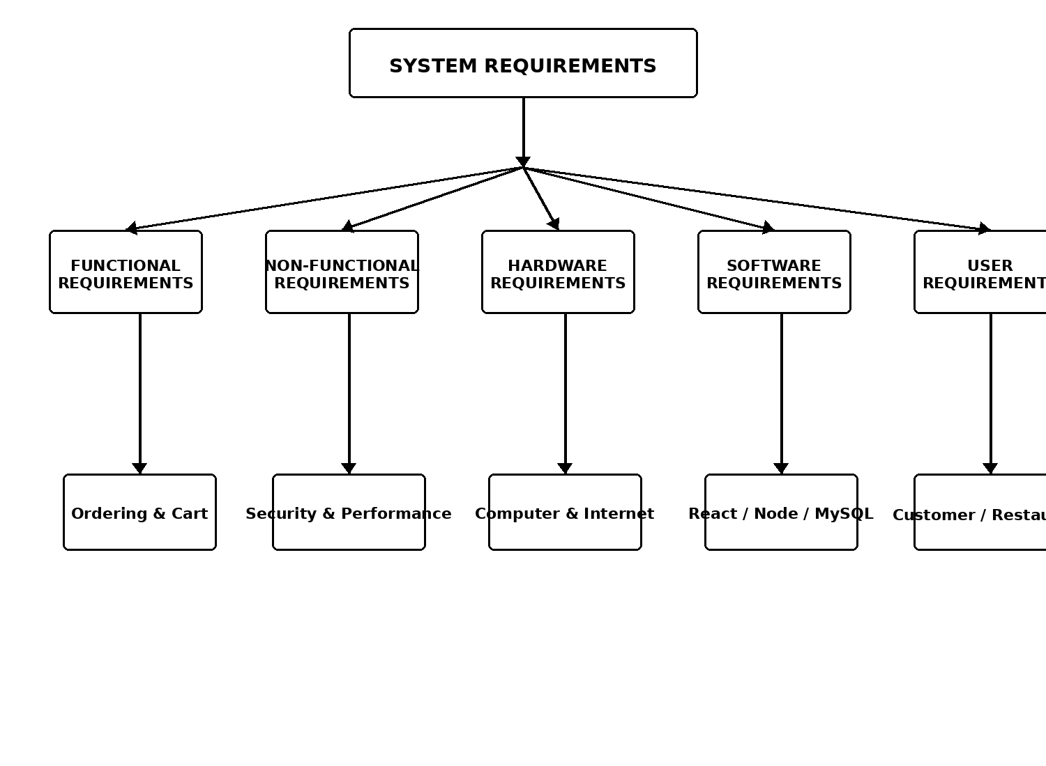

The unified cart should display the selected food items, quantities, individual prices,restaurant information, subtotal, applicable charges, and final payable amount.
Customers should be able to increase or decrease quantities and remove unwanted items before checkout.
The next requirement is the single checkout process. Once the customer confirms the cart, the system should allow the customer to complete the order through one checkout process instead of requiring a separate checkout for every restaurant.
The checkout process should display a final summary of the order before confirmation. This summary should provide sufficient information for the customer to verify the selected food items and total amount.
The system should then create a master order representing the customer's complete transaction.
The master order is one of the most important concepts in the project. It acts as the parent record for all restaurant-specific orders generated from the customer's unified cart.
For example:
The system should automatically identify the restaurant associated with each selected food item and divide the master order accordingly.
Restaurant A should receive only the items belonging to Restaurant A.
Restaurant B should receive only the items belonging to Restaurant B.
Restaurant C should receive only the items belonging to Restaurant C.
This mechanism allows the customer to experience one combined ordering process while allowing restaurants to operate independently.
The restaurant module should provide functionality for managing restaurant information and menu items.
Restaurant users should be able to add menu items, modify menu information, update prices, manage availability, and remove items where appropriate.
The restaurant should also be able to provide ingredient and allergen information for its menu items.
The restaurant should receive restaurant-specific orders generated from the master order. The restaurant should be able to accept the order and begin food preparation.
The order status should be updated as the restaurant processes the order.
A typical processing sequence can be represented as:
NEW ORDER
|
v
ACCEPTED
|
v
PREPARING
|
v
READY
|
v
HANDED TO DELIVERY
The restaurant should also be able to manage offers and discounts.
Offers can be used to communicate promotional information to customers and can be associated with applicable menu items or restaurant-level promotions.
The customer module should provide meal-time recommendations. The platform should be able to organize or recommend food based on meal periods such as breakfast, lunch, snacks, and dinner.
The system should also provide dietary preference filters. Customers should be able to filter food according to supported preferences such as vegetarian, vegan, spicy, and non-spicy options.
Another functional requirement is allergy and ingredient information.
The system should display relevant ingredient information so that customers can examine food composition before placing an order.
Where allergen information is available, the system should display it clearly.
The delivery partner module should provide functionality for managing assigned deliveries.
A delivery partner should be able to view deliveries assigned to them, accept a delivery assignment, reach the restaurant for pickup, update delivery status, and complete the delivery.
The delivery process can be represented as:

RESTAURANT
|
v
FOOD READY
|
v
DELIVERY ASSIGNMENT
|
v
DELIVERY PARTNER
|
v
PICKUP
|
v
DELIVERY
|
v
COMPLETED
The platform should also support order tracking.
Customers should be able to see the progress of their order after checkout. Since the master order may contain restaurant-specific orders with different processing times, the tracking interface should provide information about the progress of the overall transaction.
For example:
MASTER ORDER
|
+---- Restaurant A → Preparing
|
+---- Restaurant B → Ready
|
+---- Restaurant C → Delivered
The system should maintain these individual statuses while still providing a consolidated customer view.
The platform should provide a rating and review system. After an order is completed, customers should be able to provide feedback.
The administrator module should provide centralized control over the platform.
Administrators should be able to manage customer accounts, restaurant accounts, delivery partners, orders, commissions, offers, and discounts.
The administrator should also be able to monitor overall system activity.
The major functional requirements can therefore be summarized as:
CUSTOMER
|
+-- Browse Restaurants
+-- Search
+-- View Menu
+-- Select Food
+-- Unified Cart
+-- Single Checkout
+-- Payment
+-- Track Orders
+-- Ratings and Reviews
+-- Recommendations
+-- Dietary Filters
+-- Ingredient / Allergen Information

RESTAURANT
|
+-- Manage Menu
+-- Manage Ingredients
+-- Manage Allergens
+-- Receive Orders
+-- Process Orders
+-- Update Status
+-- Manage Offers

DELIVERY PARTNER
|
+-- View Assignments
+-- Accept Delivery
+-- Pickup
+-- Delivery
+-- Update Status
+-- Location Tracking

ADMINISTRATOR
|
+-- Manage Customers
+-- Manage Restaurants
+-- Manage Delivery Partners
+-- Monitor Orders
+-- Manage Commissions
+-- Manage Offers

2.2 System Requirements Overview
The complete system requirements can be organized into several major categories.
Figure 2.1: System Requirements Classification
The functional requirements define what the system does, while non-functional requirements define how effectively the system should perform those functions.
Hardware requirements define the physical resources needed to develop, test, and operate the application.
Software requirements define the operating environment, development tools, frameworks, database systems, APIs, and other software components required by the project.
User requirements define what each category of user expects from the application.
Database and communication requirements define how information should be stored and transferred between the major components.

2.3 Non-Functional Requirements
Non-functional requirements define the quality characteristics expected from the system.
These requirements are important because simply implementing features is not sufficient for a complete software system. The platform should also be usable, reliable, secure, maintainable, scalable, and responsive.
Usability
The application should provide a simple and understandable interface.
Customers should be able to navigate from restaurant browsing to menu selection, cart management, checkout, and order tracking without unnecessary complexity.
Restaurant users should be provided with interfaces focused on menu and order management.
Delivery partners should be presented with delivery-related information.
Administrators should be provided with centralized management functionality.
The interface should use clear labels, buttons, navigation elements, forms, and status indicators.
Performance
The system should respond efficiently to normal user operations.
Restaurant listings should load within an acceptable time.
Menu information should be retrieved efficiently.
Adding or removing items from the cart should provide immediate feedback.
Checkout operations should process information without unnecessary delay.
Database queries should be designed so that increasing amounts of data do not unnecessarily degrade system performance.
Reliability
The system should maintain correct information during the complete ordering process.
If a customer places a master order containing items from three restaurants, the system should preserve all three restaurant relationships correctly.
The system should avoid situations where food items are assigned to an incorrect restaurant.
Order status updates should also be associated with the correct order.
Security
The application should protect user accounts and sensitive information.
Authentication should be required for protected functionality.
Authorization should ensure that users can access only the operations associated with their role.
For example, a customer should not be able to access the restaurant menu-management interface.
A restaurant should not be allowed to modify another restaurant's menu.
A delivery partner should access only the delivery operations assigned to them.
Administrative operations should be restricted to authorized administrators.
Maintainability
The application should be divided into logical modules.
Frontend components should be organized according to their purpose.
Backend routes and controllers should be separated logically.
Database tables should have clear relationships.
This organization makes it easier to identify and modify individual components when requirements change.
Scalability
The proposed system should be capable of supporting future expansion.
The architecture should allow additional restaurants and delivery partners to be added without redesigning the complete application.
The platform should also be capable of expanding to additional cities in future versions.
Availability
The deployed application should remain accessible to authorized users when required.
Availability depends on the hosting environment, backend server, database server, network connection, and external services.
Compatibility
The web application should work with modern browsers.
The interface should be designed to operate on commonly used desktop and laptop screen sizes and should be adaptable to smaller screens where responsive design is implemented.
Real-Time Responsiveness
Order status and delivery information may change frequently.
The proposed use of Socket.io should allow important changes to be communicated in real time.
This reduces the need for customers to repeatedly refresh the application to obtain updated information.

2.4 Hardware Requirements
The development and operation of the system require general-purpose computing hardware.
Development Computer
A computer is required for developing the frontend, backend, and database components.
The development machine should have sufficient processing capability to run:
- Visual Studio Code
- Web browser
- Node.js
- React/Vite development server
- Express backend server
- MySQL
- Database management software
- Testing tools
A system with approximately 8 GB RAM or more is suitable for comfortable development of the complete project.
Adequate storage should also be available for source code, project dependencies, databases, documentation, and development tools.
Client Device
Customers, restaurants, delivery partners, and administrators require a device capable of running a modern web browser.
Possible client devices include:
- Desktop computers
- Laptops
- Tablets
- Supported smartphones
The exact supported devices depend on the final responsive implementation.
Server
The complete target architecture requires server infrastructure for running the backend application.
The server should be capable of running Node.js and Express.js and communicating with the MySQL database.
The required server capacity depends on:
- Number of users
- Number of restaurants
- Number of orders
- Database size
- Number of simultaneous requests
- Real-time communication requirements
Network
An internet connection is required for accessing the deployed web application and external services.
The network is especially important for:
- Restaurant browsing
- API communication
- Database communication
- Payment processing
- Mapping
- Real-time updates

2.5 Software Requirements
The proposed system uses several software technologies.
Operating System
The development environment can use a modern operating system capable of supporting Node.js, React development tools, MySQL, and Visual Studio Code.
Windows, Linux, and macOS can support the development environment when the required software is installed correctly.
Visual Studio Code
Visual Studio Code can be used as the primary source-code development environment.
It provides:
- Project Explorer
- Source-code editing
- Integrated terminal
- Extensions
- Debugging
- Git integration
- File management
The frontend and backend source code can be maintained within organized project folders.
React.js
React.js is used for creating the frontend.
The component-based architecture allows the application to be divided into reusable interface elements.
Examples include:
Navigation Bar
Restaurant Card
Menu Card
Cart Component
Checkout Component
Order Status Component
Dashboard
Review Form
Filter Component
React allows these components to be combined into different pages and role-specific interfaces.
Vite
Vite can be used as the frontend development and build tool.
It provides a development server and supports efficient frontend development.
The React/Vite environment allows developers to modify frontend code and immediately observe changes in the browser during development.
Node.js
Node.js is used as the proposed backend runtime.
It provides the execution environment for server-side JavaScript.
The backend can process API requests, communicate with the database, manage authentication, and coordinate different application operations.
Express.js
Express.js is used as the backend REST API framework.
The backend can provide endpoints for:
/api/auth
/api/restaurants
/api/menu
/api/orders
/api/payments
/api/deliveries
/api/reviews
/api/offers
/api/admin
These endpoints allow the React frontend to communicate with backend services.
MySQL
MySQL is used as the proposed relational database.
The database can contain tables representing users, restaurants, menu items, master orders, restaurant orders, order items, payments, deliveries, reviews, and offers.
Socket.io
Socket.io is proposed for real-time communication.
It can be used to transmit events when:
- Restaurant accepts an order
- Restaurant changes order status
- Food becomes ready
- Delivery is assigned
- Delivery status changes
- Order is completed
Google Maps API
Google Maps API is proposed for location-related features.
It can support:
- Location display
- Delivery location
- Route-related information
- Delivery tracking
Payment Service
The proposed architecture includes online payment functionality using the payment technology specified for the project.
The payment component should integrate with the checkout process so that the customer can complete the unified transaction.

2.6 User Requirements
The system contains four main categories of users.
Customer Requirements
Customers require a simple interface for discovering restaurants and ordering food.
A customer should be able to:
- Create an account.
- Log into the platform.
- Browse restaurants.
- Search for restaurants.
- View restaurant menus.
- View food details.
- Select food items.
- Add food from multiple restaurants to a unified cart.
- Modify cart quantities.
- Remove cart items.
- View the complete order total.
- Complete a single checkout.
- Make payment.
- View the master order.
- Track restaurant-specific order progress.
- View delivery information.
- Provide ratings.
- Submit reviews.
- Use dietary filters.
- View ingredient information.
- View allergen information.
- Receive meal-time recommendations.
Restaurant Requirements
Restaurants require a dedicated interface for operational management.
A restaurant should be able to:
- Log into the restaurant dashboard.
- Manage restaurant information.
- Add menu items.
- Update menu items.
- Remove menu items.
- Update food prices.
- Maintain food availability.
- Add ingredient information.
- Maintain allergen information.
- Receive restaurant-specific orders.
- Accept orders.
- Process orders.
- Update order status.
- Mark orders as ready.
- Manage offers.
- Manage discounts.
Delivery Partner Requirements
Delivery partners require a focused delivery interface.
A delivery partner should be able to:
- Log into the delivery dashboard.
- View assigned deliveries.
- Accept delivery assignments.
- View restaurant information.
- Manage pickup.
- Update pickup status.
- Manage delivery.
- Update delivery status.
- View relevant customer delivery information.
- Support location-related tracking.
Administrator Requirements
The administrator requires broader access.
An administrator should be able to:
- Manage customers.
- Manage restaurants.
- Manage delivery partners.
- Monitor orders.
- View platform-level order information.
- Manage commissions.
- Manage offers.
- Manage discounts.
- Monitor platform operations.
- Maintain administrative control over the system.
User Requirement Structure
Figure 2.2: User Requirement Structure
The four user groups interact with different sections of the same platform. Their responsibilities are separated through role-based access and dedicated interfaces.

2.7 Database Requirements
The database is one of the most important components of the complete system.
The application contains many entities that need to maintain relationships with one another.
The database should store information about users.
The user information can include:
- User ID
- Name
- Email
- Password information
- Contact information
- Role
- Account status
Restaurants require their own records.
Restaurant information can include:
- Restaurant ID
- Restaurant name
- Address
- Contact information
- Operating information
- Restaurant status
Menu items should be connected to restaurants.
Each menu item can contain:
- Menu item ID
- Restaurant ID
- Food name
- Description
- Price
- Category
- Ingredients
- Allergen information
- Dietary information
- Availability
The master order should contain information representing the customer's complete transaction.
A master order can include:
- Master Order ID
- Customer ID
- Order date
- Total amount
- Payment information
- Overall order status
Restaurant orders should be connected to the master order.
A restaurant order can include:
- Restaurant Order ID
- Master Order ID
- Restaurant ID
- Restaurant-specific total
- Restaurant order status
- Preparation information
Order items should connect individual food items with restaurant orders.
A conceptual structure is:
MASTER ORDER
|
+---- RESTAURANT ORDER A
| |
| +---- ORDER ITEM
| +---- ORDER ITEM
|
+---- RESTAURANT ORDER B
|
+---- ORDER ITEM
+---- ORDER ITEM
Payments should maintain transaction-related information.
Deliveries should maintain information about delivery assignments and delivery status.
Reviews should maintain customer feedback.
Offers should maintain promotional information.
The database should use appropriate primary keys and foreign keys to preserve relationships.
For example:
Users
|
+---- Master Orders
|
+---- Restaurant Orders
|
+---- Order Items
|
+---- Menu Items
|
+---- Restaurants
This structure allows the system to retrieve information through relationships rather than storing unnecessary duplicate data.

2.8 Communication Requirements
The complete target system requires communication between several layers.
The frontend communicates with the backend through REST APIs.
The basic communication process is:
REACT FRONTEND
|
| HTTP REQUEST
v
NODE.JS + EXPRESS
|
| PROCESS REQUEST
v
APPLICATION LOGIC
|
| DATABASE QUERY
v
MYSQL
|
| DATABASE RESPONSE
v
APPLICATION LOGIC
|
v
EXPRESS API
|
v
REACT FRONTEND
For example, when the customer requests restaurant information, the frontend can send a request to the restaurant API.
The backend processes the request and retrieves the required records from MySQL.
The backend then sends the restaurant information back to the frontend.
The frontend displays the information to the customer.
The same communication model can be used for menus, orders, deliveries, reviews, and administrative information.

2.9 Real-Time Communication Requirements
The proposed platform includes real-time functionality.
Normal REST API communication follows a request-and-response model.
However, order status changes can occur after the customer has already opened the tracking page.
For example, a restaurant may accept an order after the customer has submitted it.
The restaurant may then mark it as preparing.
Later, the restaurant may mark it as ready.
These changes should be communicated to the customer interface efficiently.
The proposed real-time communication process is:
RESTAURANT
|
| Status Change
v
BACKEND SERVER
|
| Socket Event
v
SOCKET.IO
|
v
CUSTOMER INTERFACE
|
v
UPDATED ORDER STATUS
The same concept can be applied to delivery status.

2.10 Security Requirements
Security is necessary because the platform contains accounts and transaction-related information.
The system should provide authentication.
Users should log in using their appropriate credentials.
After authentication, the system should identify the user's role.
The application should then provide only the functions associated with that role.
For example:
Customer Login
|
v
Customer Dashboard

Restaurant Login
|
v
Restaurant Dashboard

Delivery Login
|
v
Delivery Dashboard

Admin Login
|
v
Admin Dashboard
Passwords should be securely handled during backend implementation.
Protected API endpoints should verify the identity and authorization of the requesting user.
The system should also validate input data before processing it.
This is particularly important for:
- Registration
- Login
- Menu creation
- Order creation
- Payment information
- Review submission
- Administrative operations

2.11 Performance Requirements
The platform should provide acceptable response times for normal operations.
The frontend should avoid unnecessary loading operations.
The backend should process API requests efficiently.
Database queries should be optimized where necessary.
The system should also be capable of handling multiple users accessing the platform.
Performance becomes increasingly important when the number of restaurants and orders increases.
For example, restaurant search should not require retrieving unnecessary information from unrelated tables.
Similarly, viewing one customer's order history should not require loading the complete order history of every customer.

2.12 Reliability Requirements
Reliability means that the system should behave consistently and preserve correct information.
The most important reliability requirement concerns the master-order mechanism.
If the customer selects food from three restaurants, the system should correctly maintain the relationship:
MASTER ORDER
|
+---- Restaurant A Order
|
+---- Restaurant B Order
|
+---- Restaurant C Order
If Restaurant A changes its status, the system should not incorrectly modify Restaurant B's status.
If Restaurant B completes its order, the system should preserve the status of Restaurant A and Restaurant C independently.
The customer should continue to see a consolidated representation of the overall transaction.

2.13 Data Integrity Requirements
Data integrity ensures that the database contains accurate and valid information.
Primary keys should uniquely identify records.
Foreign keys should connect related records.
For example, every restaurant order should refer to a valid master order.
Every restaurant order should also refer to a valid restaurant.
Every order item should refer to a valid restaurant order and menu item.
The database should prevent invalid relationships wherever possible.
The system should also validate required fields before inserting records.
For example, an order should not be created without a valid customer.
A restaurant-specific order should not be created without a valid restaurant.
An order item should not be created without a valid menu item.

2.14 Scalability Requirements
The platform should support future growth.
The database design should allow new restaurants to be added without changing the basic database structure.
New customers and delivery partners should also be supported through normal registration and administrative processes.
The system should be capable of supporting increasing numbers of orders.
The architecture should also allow the platform to expand to multiple cities.
Future expansion can include:
More Restaurants
|
v
More Delivery Partners
|
v
More Cities
|
v
More Customers
|
v
More Orders
|
v
Larger Database
The architecture should therefore be designed with scalability in mind from the beginning.

2.15 Maintainability Requirements
The project should be organized in a modular manner.
Frontend components should be separated according to their functionality.
Backend APIs should be organized into logical routes.
Database tables should have clear relationships.
External services should be integrated through clearly defined modules.
A modular architecture makes it easier to update individual parts of the system.
For example, changes to the restaurant interface should not require rewriting the complete customer interface.
Similarly, changes to the database should be handled through the appropriate backend layer rather than directly from the frontend.

2.16 Overall System Requirement Flow
The overall requirements can be understood through the following conceptual sequence:
USER
|
v
FRONTEND INTERFACE
|
v
USER-SPECIFIC FUNCTIONALITY
|
v
BACKEND APIs
|
v
BUSINESS LOGIC
|
v
DATABASE
|
+------------------+
| |
v v
REAL-TIME EXTERNAL
SERVICES SERVICES
| |
v v
Socket.io Maps / Payment
The system requirements establish the foundation for the remaining design and implementation stages of the project. They define the expected behavior of the platform and identify the resources required to build it.
The most important requirement is the ability to combine customer-level unified ordering with restaurant-level independent processing. All other requirements, including database design, APIs, order tracking, delivery management, and real-time communication, support this central objective.

CHAPTER 3 – TECHNOLOGY STACK
The Online Food Delivery Platform is designed using a combination of frontend technologies, backend technologies, database technologies, real-time communication tools, external services, and development tools. The technology stack is selected to support the major requirements of the proposed system, including multi-restaurant ordering, unified checkout, restaurant-specific order processing, delivery management, order tracking, user management, and administrative operations.
The proposed technology architecture separates the application into different layers. React.js and Vite are used for the frontend development environment, while Node.js and Express.js form the planned backend layer. MySQL is used for persistent relational data storage. Socket.io is included for real-time communication. External services such as Google Maps and the proposed payment technology support location and payment-related functionality. Git and GitHub support version control, while tools such as Visual Studio Code and Postman support development and testing.
The frontend prototype currently demonstrates the main interface and application flows using a service layer and mock data. The Node.js, Express.js, MySQL, Socket.io, mapping, and payment components form the target full-stack architecture for the complete system.

3.1 Front-End Technologies
The frontend is the visible part of the Online Food Delivery Platform. It is responsible for displaying information to users and receiving user interactions.
The proposed frontend uses React.js with Vite, together with JavaScript ES6+ and React Router.
The frontend is designed to support the four major roles:
Customer
|
Restaurant
|
Delivery Partner
|
Administrator
Each role requires different interfaces and operations, but all interfaces belong to the same overall platform.
The frontend should provide a consistent navigation structure while displaying role-specific functionality.
React.js
React.js is the primary frontend framework used for constructing the user interface.
React follows a component-based development approach. Instead of creating one large page containing all functionality, the application can be divided into smaller reusable components.
Examples of reusable components include:
- Navigation bar
- Restaurant card
- Food item card
- Search bar
- Category selector
- Cart item
- Checkout section
- Order status component
- Review component
- Profile component
- Dashboard cards
- Modal dialogs
- Forms
For example, a restaurant card can be designed once and reused for multiple restaurants.
Restaurant Card Component
|
+---- Restaurant A
|
+---- Restaurant B
|
+---- Restaurant C
|
+---- Restaurant D
This reduces repeated code and makes the frontend easier to maintain.
React also supports state-based rendering. When the state of an application changes, the appropriate interface components can update accordingly.
For example, when a customer adds a food item to the cart, the cart count and cart contents can update without requiring the entire page to be manually recreated.
React Components
The frontend can be divided into several component groups.
Common components may include navigation and reusable interface elements.
Page components represent complete application pages such as home, restaurant details, cart, checkout, order history, profile, and dashboards.
A conceptual structure is:
src
|
+-- components
| |
| +-- Navbar
| +-- RestaurantCard
| +-- FoodCard
| +-- CartItem
|
+-- pages
| |
| +-- Home
| +-- Restaurants
| +-- Menu
| +-- Cart
| +-- Checkout
| +-- Orders
| +-- Profile
|
+-- services
|
+-- data
|
+-- styles
|
+-- App
|
+-- main
The current project documentation identifies separation of components, pages, contexts, data, services, and styling concerns as part of the frontend structure.
Vite
Vite provides the frontend development and build environment.
It is used with React to create and run the frontend application during development.
A Vite-based development process allows the developer to start a local development server and observe frontend changes in the browser.
The basic development process is:
React Source Code
|
v
Vite Development Server
|
v
Web Browser
|
v
Frontend Interface
Vite also provides a production build process through which the frontend source code can be prepared for deployment.
JavaScript ES6+
JavaScript is used for application logic and interaction.
Modern JavaScript features are useful for:
- Variables and constants
- Functions
- Arrow functions
- Objects
- Arrays
- Destructuring
- Modules
- Promises
- Async/await
- Event handling
- API requests
- State-related operations
Asynchronous JavaScript is particularly important when the frontend communicates with backend APIs.
For example, the frontend may request restaurant information from the backend and wait for the response before displaying the data.
React Router
React Router can be used to manage navigation between frontend pages.
A typical customer navigation structure can include:
Login
|
v
Home
|
+---- Restaurants
|
+---- Menu
|
+---- Cart
|
+---- Checkout
|
+---- Order Confirmation
|
+---- Order History
|
+---- Profile
Role-specific routes can also be created.
For example:
Restaurant
|
v
Restaurant Dashboard
|
+---- Menu Management
+---- Orders
+---- Offers

Delivery Partner
|
v
Delivery Dashboard
|
+---- Assigned Orders
+---- Pickup
+---- Delivery Status

Administrator
|
v
Admin Dashboard
Protected routes can be used so that users cannot directly access pages belonging to another role.

3.2 Front-End State Management
State management is important because several parts of the application depend on changing information.
The cart is one of the most important examples.
When the customer adds food items from multiple restaurants, the cart state must preserve:
- Restaurant
- Food item
- Quantity
- Price
- Selected items
- Total amount
The conceptual state can be represented as:
CART STATE
|
+---- Restaurant A
| |
| +---- Item A1
| +---- Item A2
|
+---- Restaurant B
| |
| +---- Item B1
|
+---- Restaurant C
|
+---- Item C1
The project uses context-based state management for authentication and cart information in the current frontend prototype.
Authentication state can determine whether a user is logged in.
Cart state can determine what food items the customer has selected.
These states can be shared among components without repeatedly passing the same information through every component.

3.3 Front-End Service Layer
The frontend can use a service layer to separate API communication from visual components.
Instead of placing all API request logic directly inside page components, the service layer can provide functions for communication with the backend.
A conceptual structure is:
React Page
|
v
Service Layer
|
v
REST API
|
v
Express Backend
For example, the service layer can contain functions such as:
loginUser()
registerUser()
getRestaurants()
getMenu()
createOrder()
getOrderHistory()
getDeliveryStatus()
submitReview()
This structure improves maintainability because the API communication logic is kept separate from the user interface.
The current prototype uses mock data through the service layer. During full-stack integration, these service functions can be connected to the actual Node.js and Express.js APIs.

3.4 Backend Technologies
The planned backend architecture uses Node.js and Express.js.
The backend forms the middle layer between the frontend, database, and external services.
Its main responsibilities include:
- Receiving API requests
- Validating input
- Authenticating users
- Authorizing users
- Applying business rules
- Processing orders
- Communicating with MySQL
- Coordinating payment operations
- Managing delivery information
- Sending responses to the frontend
- Supporting real-time events
The backend can therefore be represented as:
React Frontend
|
v
Node.js + Express.js
|
+---- Business Logic
|
+---- MySQL
|
+---- Socket.io
|
+---- External Services
Node.js
Node.js provides the runtime environment for executing JavaScript on the server side.
Using Node.js allows JavaScript to be used across both frontend and backend development.
This provides a consistent programming environment for the project.
Node.js can handle multiple API requests and communicate with databases and external services through appropriate libraries.
Express.js
Express.js is used as the backend web framework.
It provides routing and middleware functionality for creating REST APIs.
The backend can be divided into logical routes.
For example:
/api/auth
/api/users
/api/restaurants
/api/menu
/api/cart
/api/orders
/api/payments
/api/deliveries
/api/reviews
/api/offers
/api/admin
Each route group can handle a particular area of the application.
For example, restaurant routes can provide operations related to restaurant information, while order routes can handle master-order and restaurant-order processing.
REST APIs
The frontend and backend communicate through REST APIs.
The basic process is:
Frontend
|
| HTTP Request
v
Express API
|
| Process
v
Database / Business Logic
|
| JSON Response
v
Frontend
The REST API can support operations such as:
GET → Retrieve information
POST → Create information
PUT → Update information
PATCH → Partially update information
DELETE → Remove information
For example:
GET /restaurants
can retrieve restaurant information.
Similarly:
GET /restaurants/:id/menu
can retrieve menu information for a particular restaurant.
An order creation operation could use a POST request.

3.5 Backend Middleware
Express.js middleware can be used to process requests before they reach the main business logic.
Middleware can be used for:
- CORS
- Authentication
- Authorization
- Input validation
- Logging
- Error handling
- Request processing
For example:
Client Request
|
v
CORS Middleware
|
v
Authentication
|
v
Authorization
|
v
Validation
|
v
Controller
|
v
Database
This approach allows common processing operations to be implemented centrally rather than repeatedly inside every API endpoint.

3.6 Business Logic Layer
The backend should contain the business rules of the application.
The master-order mechanism is one of the most important business rules.
Suppose the customer selects:
Restaurant A
Item A1
Item A2

Restaurant B
Item B1

Restaurant C
Item C1
The backend should first create a master order.
It should then group the selected items according to restaurant.
The resulting structure is:
MASTER ORDER
|
+---- Restaurant A Order
| |
| +---- A1
| +---- A2
|
+---- Restaurant B Order
| |
| +---- B1
|
+---- Restaurant C Order
|
+---- C1
This is a core part of the backend business logic.
The frontend should not be responsible for independently maintaining restaurant-level order processing rules.
Instead, the backend should receive the unified order information and apply the required business rules.

3.7 Database Technology
MySQL is the primary relational database selected for the proposed full-stack architecture.
The system contains many structured relationships.
For example:
Customer
|
+---- Orders
|
+---- Restaurant Orders
|
+---- Order Items
|
+---- Menu Items
|
+---- Restaurant
A relational database is suitable for maintaining these relationships.
The main entities include:
- Users
- Restaurants
- Menu Items
- Master Orders
- Restaurant Orders
- Order Items
- Payments
- Deliveries
- Reviews
- Offers
Users Table
The Users table can store user-related information.
Possible information includes:
User ID
Name
Email
Password
Role
Contact Information
Account Status
The role field is particularly important for role-based access.
Restaurants Table
The Restaurants table stores restaurant information.
Possible information includes:
Restaurant ID
Restaurant Name
Address
Contact
Status
Operating Information
Menu Items Table
The Menu Items table stores food information.
Possible information includes:
Menu Item ID
Restaurant ID
Food Name
Description
Price
Category
Ingredients
Allergen Information
Dietary Information
Availability
Master Orders Table
The Master Orders table represents the complete customer transaction.
It can contain:
Master Order ID
Customer ID
Order Date
Total Amount
Payment Status
Overall Order Status
Restaurant Orders Table
Restaurant Orders represent the individual restaurant portions of the master order.
It can contain:
Restaurant Order ID
Master Order ID
Restaurant ID
Restaurant Total
Restaurant Order Status
Order Items Table
Order Items connect individual food selections to restaurant orders.
It can contain:
Order Item ID
Restaurant Order ID
Menu Item ID
Quantity
Price
Subtotal
Database Relationships
The database relationships can be represented as:
Users
|
v
Master Orders
|
v
Restaurant Orders
|
v
Order Items
|
v
Menu Items
|
v
Restaurants
Primary keys uniquely identify records, while foreign keys connect related records.
Normalization can be used to reduce unnecessary duplication.

3.8 Real-Time Technology – Socket.io
Socket.io is proposed for real-time communication.
Traditional API communication generally follows a request-response process.
For example:
Customer
|
| Request
v
Server
|
| Response
v
Customer
However, order status changes may occur without the customer sending a new request.
Socket.io can support event-based communication.
For example:
Restaurant
|
| "Order Ready"
v
Backend
|
| Socket Event
v
Customer
This can be used for:
- Order acceptance
- Food preparation status
- Food readiness
- Delivery assignment
- Pickup status
- Delivery status
- Order completion
This technology is especially relevant to the project's requirement for real-time order and delivery updates.

3.9 Google Maps API
Google Maps API is proposed for location and delivery-related functionality.
The delivery system can use map-related services to support location information.
A conceptual process is:
Customer Location
|
v
Restaurant Location
|
v
Delivery Route
|
v
Delivery Partner
|
v
Customer
The mapping component can assist with location visualization and delivery-related information.
The exact map features depend on the final integration and API configuration.

3.10 Payment Technology
The platform requires online payment functionality because the customer completes a unified checkout.
The project documentation identifies x402 Aragen as the proposed payment technology.
The payment component should be integrated with the checkout process.
A conceptual payment flow is:
Unified Cart
|
v
Checkout
|
v
Payment Request
|
v
Payment Service
|
v
Payment Result
|
+---- SUCCESS
|
+---- FAILURE
After successful payment, the backend can proceed with master-order creation and restaurant-specific order generation according to the implemented transaction logic.
Payment-related information should be handled securely and should not be unnecessarily exposed to the frontend.

3.11 Version Control – Git
Git is used for tracking changes in the project source code.
As the project develops, many files are created and modified.
Git allows developers to maintain a history of changes.
A typical process is:
Write Code
|
v
Test Code
|
v
Git Add
|
v
Git Commit
|
v
Git Push
|
v
GitHub Repository
Version control is useful when multiple team members work on the same project.
It also allows developers to identify changes and recover previous versions when necessary.

3.12 GitHub
GitHub can be used as the remote repository for the project.
The repository can contain:
Project Repository
|
+---- frontend
|
+---- backend
|
+---- database
|
+---- documentation
|
+---- README
GitHub also supports collaboration and project history.
Sensitive information should not be uploaded to the repository.
Database passwords, API keys, secret tokens, and other confidential configuration values should be stored using environment variables or appropriate secret-management mechanisms.

3.13 Visual Studio Code
Visual Studio Code can be used as the primary development environment.
It provides:
- Code editor
- Project explorer
- Integrated terminal
- Extensions
- Debugging
- Git integration
- Search
- File management
The frontend and backend projects can be opened within the development environment.
The integrated terminal can be used to execute commands such as:
npm install
npm run dev
npm start
The exact commands depend on the project configuration.

3.14 npm
npm is used for managing JavaScript project dependencies.
The project can use npm to install packages required by React, Vite, Express, database connectivity, Socket.io, and other functionality.
A typical package-management workflow is:
Project
|
v
package.json
|
v
npm install
|
v
node_modules
The package.json file identifies project dependencies and scripts.
The node_modules directory contains installed packages.
The package-lock.json file can preserve dependency version information for consistent installation.

3.15 Postman
Postman can be used to test backend APIs independently from the frontend.
This is useful because backend errors can be identified without involving the graphical user interface.
For example:
Postman
|
| POST /api/auth/login
v
Express Backend
|
v
Response
Postman can be used to test:
- Registration
- Login
- Restaurant retrieval
- Menu retrieval
- Order creation
- Order status
- Delivery assignment
- Reviews
- Administrative APIs
This makes API testing easier during backend development.

3.16 Technology Stack Integration
The individual technologies do not work independently. They are combined into a complete application architecture.
Figure 3.1: Technology Stack of the Proposed Platform
The overall technology relationship is:
React.js + Vite
|
v
REST API / JSON
|
v
Node.js + Express.js
|
+----------------+
| |
v v
MySQL Socket.io
| |
| v
| Real-Time Updates
|
+---- External Services
|
+---- Maps
|
+---- Payment
The technologies are therefore arranged according to their responsibilities.
React.js handles presentation.
Node.js and Express.js handle server-side operations.
MySQL handles persistent storage.
Socket.io handles real-time communication.
External services provide specialized capabilities.

3.17 Application Communication Flow
The complete communication process between the different technologies can be represented using the following diagram.
Figure 3.2: Application Communication Flow
The user interacts with the React frontend through a browser.
The frontend sends requests to the backend through REST APIs.
Express.js receives and processes the requests.
Node.js executes the backend application logic.
When persistent information is required, the backend communicates with MySQL.
The backend returns the required response to the frontend.
When real-time information is required, Socket.io can communicate status changes to connected clients.
External APIs can be accessed by the backend for mapping and payment-related functionality.

3.18 Development Workflow
The development of the application follows several stages.
First, requirements are identified and analyzed.
Second, the system design and database structure are prepared.
Third, frontend components and backend APIs are developed.
Fourth, the source code is maintained using Git and GitHub.
Fifth, APIs, frontend behavior, and database operations are tested.
Finally, the complete system can be prepared for deployment.
Figure 3.3: Development Workflow
The development process can therefore be summarized as:
Requirement Analysis
|
v
System Design
|
v
Frontend Development
|
v
Backend Development
|
v
Database Development
|
v
API Integration
|
v
Testing
|
v
Deployment
Each stage depends on the previous stages.
A clear requirements analysis reduces unnecessary changes during implementation.
A well-designed database reduces problems during backend development.
A properly structured API layer makes frontend-backend integration easier.
Testing throughout development helps identify problems before final deployment.

3.19 Technology Selection for Different Modules
Different technologies are used for different responsibilities.
System Requirement | Technology
User Interface | React.js
Frontend Development Server | Vite
Application Logic | JavaScript ES6+
Navigation | React Router
Backend Runtime | Node.js
REST APIs | Express.js
Persistent Database | MySQL
Real-Time Updates | Socket.io
Location Services | Google Maps API
Payment | Proposed x402 Aragen
Version Control | Git
Remote Repository | GitHub
Development Environment | Visual Studio Code
API Testing | Postman
The technology selection follows the functional requirements of the system.
The frontend technology must support dynamic user interfaces.
The backend technology must support API development and business logic.
The database must support structured relationships.
The real-time technology must support continuous status communication.
External services must provide specialized functions such as maps and payments.
Development tools must support collaboration, testing, debugging, and source-code management.

3.20 Relationship Between Current Prototype and Target Architecture
An important distinction exists between the current frontend prototype and the proposed complete architecture.
The current frontend prototype demonstrates the major user-interface flows and uses a service layer with mock data.
The prototype structure can be represented as:
React Frontend
|
v
Service Layer
|
v
Mock / Local Data
The target full-stack architecture is:
React Frontend
|
v
API Service Layer
|
v
Node.js + Express.js
|
v
MySQL Database
The target architecture additionally includes:
Node.js + Express.js
|
+---- Socket.io
|
+---- Google Maps
|
+---- Payment Service
This separation is important because it allows the frontend interface to be developed and demonstrated before the complete backend integration is finished.
The service-layer approach also provides a clear location for replacing mock data operations with real API requests.

3.21 Advantages of the Selected Technology Stack
The selected technology stack provides a structured foundation for the proposed application.
React.js supports reusable interface components.
Vite provides an efficient frontend development environment.
JavaScript provides common programming language support across frontend and backend layers.
Node.js allows server-side JavaScript execution.
Express.js simplifies REST API development.
MySQL provides structured relational storage.
Socket.io supports real-time communication.
Google Maps supports location-related functionality.
The payment technology supports the unified checkout requirement.
Git and GitHub support source-code management and collaboration.
Visual Studio Code provides an integrated development environment.
Postman supports independent API testing.
Together, these technologies provide the major components required by the proposed Online Food Delivery Platform.

3.22 Summary of Technology Stack
The technology stack can finally be summarized as follows:
ONLINE FOOD DELIVERY PLATFORM
|
------------------------------------------------
| | | |
v v v v
FRONTEND BACKEND DATABASE EXTERNAL
| | | SERVICES
v v v |
React + Vite Node + Express MySQL |
| | |
| +----------+------------------+
| |
v v
User Interface Socket.io / Maps /
Payment Integration
The technology stack is therefore organized around separation of responsibilities.
The frontend manages user interaction and presentation.
The backend manages application logic and API communication.
The database manages persistent information.
Socket.io supports real-time communication.
External services provide mapping and payment capabilities.

CHAPTER 4 – SYSTEM ARCHITECTURE
The system architecture of the Online Food Delivery Platform: Multi-Restaurant Ordering & Unified Checkout defines how the different components of the application communicate with each other. The proposed architecture follows a layered approach consisting of the frontend, backend, database, real-time communication, and external services. The system supports four major user roles: Customer, Restaurant, Delivery Partner, and Administrator. Each role interacts with the React.js frontend, while the backend manages application logic, database operations, order processing, and communication with external services.
4.1 High-Level Architecture
The high-level architecture of the proposed system can be represented as follows:
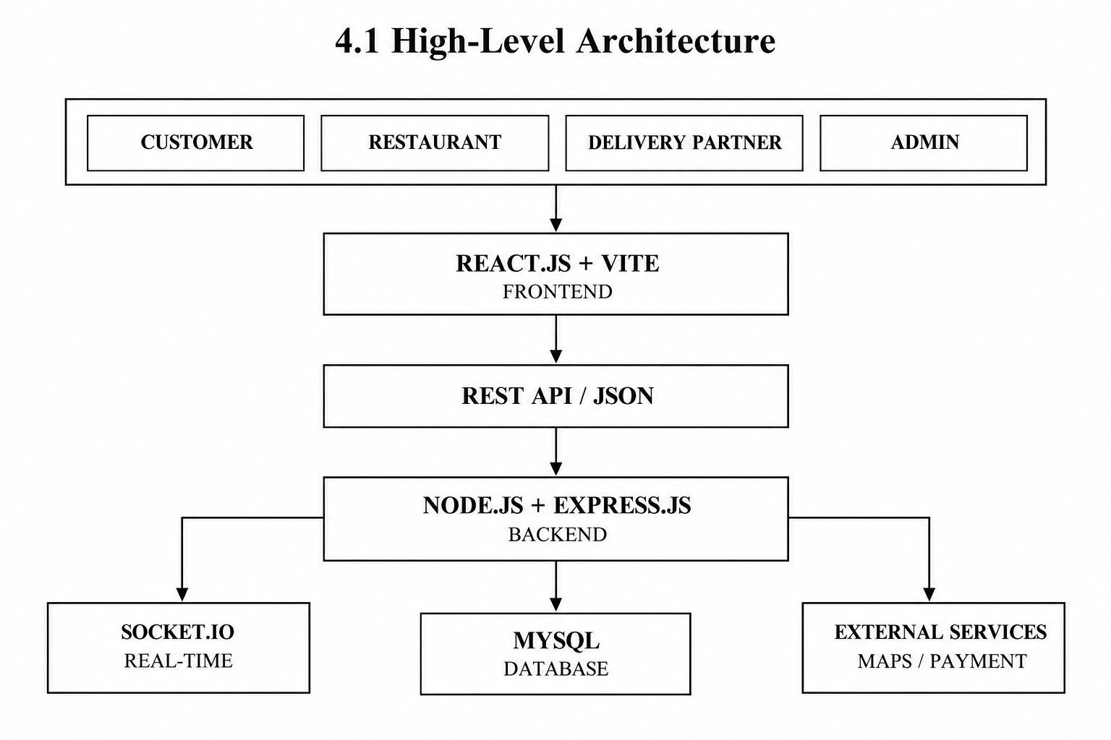

The users interact with the system through the React.js and Vite frontend. The frontend provides the required screens and interfaces for different user roles. When an operation requires backend processing, the frontend communicates with the Node.js and Express.js backend through REST APIs using JSON data.
The backend acts as the main processing layer of the application. It receives requests from the frontend, validates the information, applies the required business rules, and communicates with the MySQL database. The backend can also communicate with Socket.io and external services such as mapping and payment services where required.
MySQL is responsible for storing persistent information such as users, restaurants, menu items, orders, order items, payments, delivery assignments, reviews, and offers. Socket.io is planned for real-time communication related to order and delivery status. External services can be connected through controlled backend integrations.
One of the most important architectural concepts is the master-order mechanism. When a customer selects food items from multiple restaurants and completes a unified checkout, the system creates one master order representing the customer's complete order. The master order is then divided into restaurant-specific orders. Each restaurant can independently process its own order while the customer continues to view the complete order through a unified interface.
4.2 Frontend Layer
The frontend layer is the visible part of the application through which users interact with the system. It is developed using React.js with Vite. The frontend is responsible for displaying pages, forms, navigation elements, restaurant information, menu items, cart information, checkout details, order information, and role-specific dashboards.
The frontend provides different interfaces according to the user's role. Customers can access restaurant discovery, menu browsing, search, cart, checkout, order history, profile, reviews, recommendations, and other customer-related features. Restaurants can access menu and order-management functionality. Delivery partners can access their assigned delivery information and delivery status operations. Administrators can access management and monitoring functions.
React provides a component-based structure for the frontend. Common elements such as navigation bars, restaurant cards, food cards, buttons, forms, cart components, and dialogs can be reused across different pages. This improves consistency and makes the interface easier to maintain.
The frontend also handles user input, navigation, form validation, cart interaction, loading indicators, and presentation of responses received from the backend. React Context can be used to manage common application state such as authentication and cart information.
In the current prototype, the frontend demonstrates the main user interface and application flows using a service layer and mock/local data. The Node.js, Express.js, and MySQL components represent the target full-stack architecture that can be connected to the frontend through REST APIs.
4.3 Backend Layer
The backend layer is responsible for the main application logic and communication between the frontend, database, and external services. The proposed backend uses Node.js with Express.js.
The backend receives requests from the React frontend through REST APIs. It validates incoming information, applies business rules, performs database operations, and returns appropriate JSON responses to the frontend.
The backend handles important operations such as user authentication, role checking, restaurant management, menu operations, master-order creation, restaurant-specific order splitting, payment coordination, delivery assignment, order-status updates, reviews, and administrative operations.
The master-order mechanism is an important responsibility of the backend. When a customer places a unified order containing items from different restaurants, the backend identifies the restaurants involved and creates separate restaurant-specific orders. This allows each restaurant to process only its own items.
The backend also provides a suitable location for implementing authentication and authorization. Different users can be provided with different permissions based on their roles. Middleware can be used for authentication, authorization, request validation, CORS handling, and centralized error handling.
The separation of the backend from the frontend allows the user interface and application logic to be developed independently. Changes to the frontend do not necessarily require rewriting the database logic, provided that the API contracts remain consistent.
4.4 Database Layer
The database layer is responsible for persistent storage of application information. MySQL is used as the proposed relational database for the system.
The database stores information related to users, restaurants, menu items, master orders, restaurant-specific orders, order items, payments, delivery assignments, reviews, offers, and other related records.
Relationships between the different entities are maintained using primary keys and foreign keys. For example, a restaurant can have multiple menu items, a customer can place multiple master orders, and a master order can contain multiple restaurant-specific orders. Each restaurant-specific order can contain multiple order items.
The database is particularly important for maintaining the relationship between a master order and its restaurant-specific orders. This structure allows the system to provide a unified experience to the customer while maintaining independent processing for each restaurant.
Database normalization and appropriate relationships can be used to reduce unnecessary data duplication and maintain data consistency. The backend communicates with the database whenever information needs to be created, retrieved, updated, or deleted.
4.5 Real-Time Communication
Real-time communication is an important part of the proposed architecture for providing timely order and delivery updates. Socket.io is planned for handling real-time communication between the server and connected clients.
In a traditional request-response system, a user may need to refresh the application repeatedly to see changes in order status. With Socket.io, the backend can send relevant status updates to connected users when important events occur.
For example, when a restaurant accepts an order, starts preparing it, or marks it as ready, the customer can receive the updated status. Similarly, when a delivery partner accepts a delivery or picks up an order, the corresponding delivery status can be communicated to the relevant users.
Real-time communication can therefore improve the connection between restaurant processing, delivery operations, and customer tracking. It is planned as part of the full-stack architecture and can be integrated after the basic request-response workflow is established.
4.6 Deployment Architecture
During development, the React frontend and Node.js backend can run separately on different localhost ports. The frontend development server is responsible for running the React application, while the backend server handles API requests. MySQL can run locally through MySQL Server or an appropriate local database management environment.
A typical development structure can be represented as:

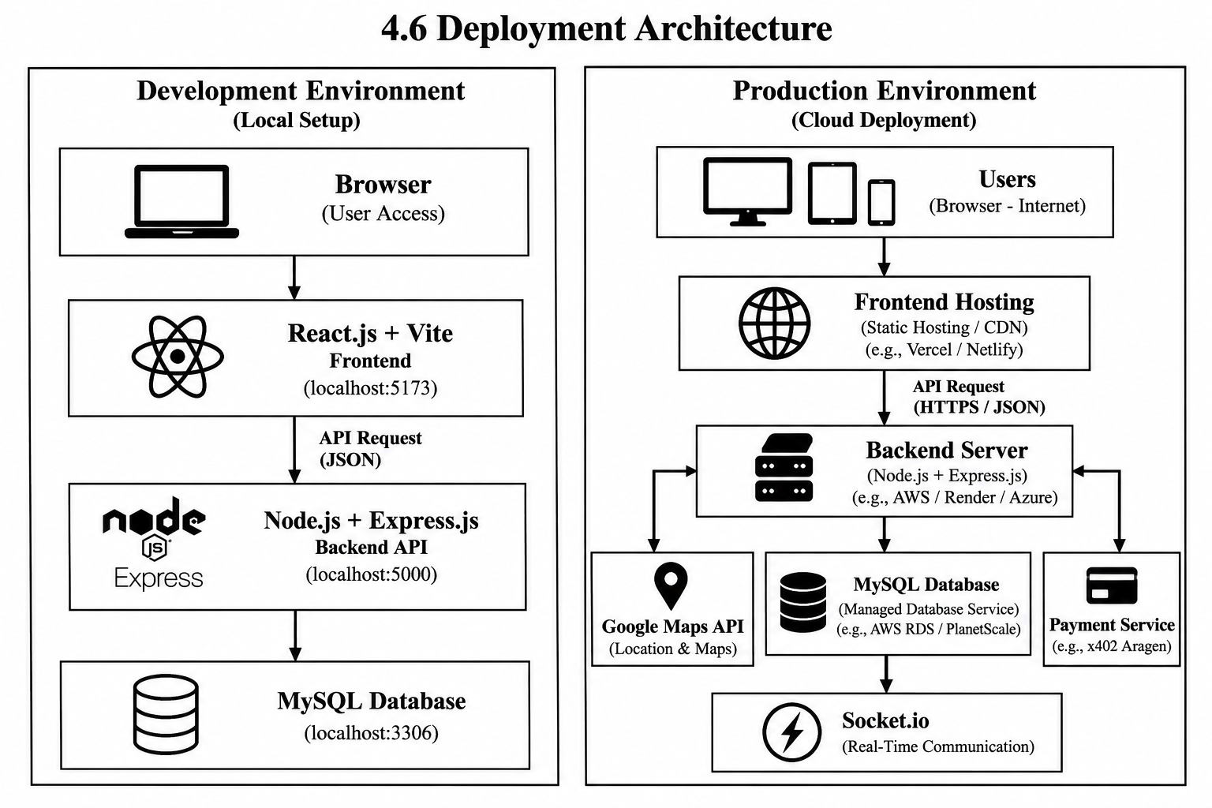
For production deployment, the frontend can be hosted on a static hosting platform or content delivery network, while the Node.js and Express.js backend can run on a cloud server. The MySQL database can be hosted using a managed database service.
The deployment architecture can also include Socket.io for real-time communication and external integrations such as Google Maps and payment services. These services should be configured separately using appropriate environment variables and credentials.
The separation of frontend, backend, and database infrastructure provides flexibility for future development and deployment. It also allows each layer to be scaled or modified independently according to the requirements of the application.
Overall, the system architecture provides a structured foundation for the Online Food Delivery Platform. The layered design separates user interaction, application logic, persistent data, real-time communication, and external services. The central master-order mechanism connects these layers by allowing a single customer order to be divided into restaurant-specific orders while maintaining a unified customer-facing order experience.

CHAPTER 5 – DESIGN
The design of the Online Food Delivery Platform: Multi-Restaurant Ordering & Unified Checkout describes the structure of the system, the interaction between different users and modules, the database entities and relationships, the flow of information, and the processing of multi-restaurant orders. The system is designed around four major user roles: Customer, Restaurant, Delivery Partner, and Administrator. The design provides a unified customer experience while allowing restaurants and delivery partners to perform their respective activities independently.
5.1 Use Case Design
The use case design describes the interactions between the users and the different functions provided by the system. The major actors in the proposed application are Customer, Restaurant, Delivery Partner, and Administrator. Each actor has specific responsibilities within the food delivery process.
The Customer can register and log in to the application, browse available restaurants, search for food items, view restaurant menus, select items from multiple restaurants, and add them to a unified cart. The customer can modify the cart, proceed to checkout, complete payment, and place an order. After placing the order, the customer can view the master order and track the status of the restaurant-specific orders and delivery process. Customers can also provide ratings and reviews after completing an order. Additional functions include viewing ingredient and allergen information, applying dietary preferences, and receiving meal-time recommendations.
The Restaurant actor can manage restaurant information and menu items. Restaurants can add, update, or remove food items and maintain relevant ingredient and allergen information. When an order is placed, the restaurant receives its restaurant-specific portion of the master order. The restaurant can accept the order, process the food, update preparation status, and manage offers or discounts.
The Delivery Partner actor can view delivery assignments, accept delivery tasks, collect prepared orders from restaurants, and complete deliveries. The delivery partner can update pickup and delivery status and provide location information when required. These updates are communicated to the appropriate parts of the system so that customers can track the progress of their orders.
The Administrator actor has centralized management responsibilities. The administrator can manage customers, restaurants, and delivery partners. The administrator can also monitor orders, commissions, and promotional offers. This provides centralized control over important platform activities.
The major use cases of the system can therefore be summarized as follows:
Customer → Register/Login → Browse Restaurants → Search Food → Select Items → Unified Cart → Checkout → Payment → Place Master Order → Track Order → Rate and Review
Restaurant → Login → Manage Restaurant → Manage Menu → Receive Order → Accept Order → Prepare Order → Update Order Status → Manage Offers
Delivery Partner → Login → View Assignment → Accept Delivery → Pickup Order → Update Status → Deliver Order
Administrator → Login → Manage Users → Manage Restaurants → Manage Delivery Partners → Monitor Orders → Manage Commissions → Manage Offers
The use case design ensures that each user receives access to the functionality required for their role while maintaining a common platform for the complete food ordering and delivery process.
5.2 ER Diagram
The Entity Relationship (ER) design represents the major entities of the Online Food Delivery Platform and the relationships between them. The database is designed around users, restaurants, menu items, orders, payments, deliveries, reviews, and other supporting entities.
The main entity is the User entity, which stores information about users registered on the platform. A user can have a specific role such as Customer, Restaurant user, Delivery Partner, or Administrator. Customer-related information is connected with orders placed by the customer.
The Restaurant entity stores information about restaurants available on the platform. A restaurant can have multiple menu items. Therefore, there is a one-to-many relationship between Restaurant and Menu Item. Each menu item belongs to a particular restaurant and contains information such as item name, price, description, category, ingredients, and allergen information.
The Master Order entity represents the complete order placed by a customer. A customer can place multiple master orders, while each master order belongs to one customer. A master order can contain items from multiple restaurants.
The Restaurant Order entity represents the restaurant-specific portion of a master order. One master order can therefore be associated with multiple restaurant orders. Each restaurant order belongs to one restaurant and contains the food items that were selected from that restaurant.
The Order Item entity stores individual food items included within a restaurant order. Each order item is associated with a particular menu item and stores information such as quantity and price.
The Payment entity stores information related to payment for an order. A payment is associated with the corresponding order and contains information required to record the payment transaction and its status.
The Delivery entity represents delivery-related information. A restaurant order or delivery assignment can be associated with a delivery partner who is responsible for completing the delivery. The delivery entity can store information such as delivery partner, pickup status, delivery status, and relevant timestamps.
The Review entity stores customer feedback for completed food orders or restaurants. A customer can provide reviews and ratings based on their ordering experience.
The major relationships in the ER design are:
Customer → places → Master Order
Master Order → contains → Restaurant Orders
Restaurant → receives → Restaurant Orders
Restaurant → has → Menu Items
Restaurant Order → contains → Order Items
Order Item → refers to → Menu Item
Master Order → has → Payment
Restaurant Order → has → Delivery
Delivery Partner → handles → Delivery
Customer → provides → Review
Restaurant → receives → Review
This ER structure supports the master-order mechanism and maintains the relationship between the overall customer order and the individual restaurant orders.
5.3 Database Schema
The database schema defines the tables required for storing and managing the information of the food delivery platform. MySQL is used as the proposed relational database management system. The schema is designed to maintain data consistency and establish relationships between different entities.
The Users table stores user information such as user ID, name, email, password information, phone number, address, and role. The role field helps identify whether the user is a customer, restaurant user, delivery partner, or administrator.
The Restaurants table stores information about restaurants, including restaurant ID, restaurant name, address, contact information, description, and other relevant details. Each restaurant can have multiple menu items.
The Menu_Items table stores food-related information such as menu item ID, restaurant ID, item name, description, category, price, availability, ingredients, and allergen information. The restaurant ID acts as a reference connecting each menu item with its restaurant.
The Master_Orders table stores the main order information. It can contain fields such as master order ID, customer ID, order date, total amount, payment status, and overall order status. The customer ID connects the master order with the customer who placed it.
The Restaurant_Orders table stores the individual restaurant-specific orders created from a master order. It contains information such as restaurant order ID, master order ID, restaurant ID, order status, subtotal, and timestamps. The master order ID connects the restaurant-specific order to the complete customer order.
The Order_Items table stores individual items included in restaurant orders. It can contain order item ID, restaurant order ID, menu item ID, quantity, item price, and subtotal.
The Payments table stores payment-related information such as payment ID, master order ID, payment amount, payment method, transaction reference, and payment status.
The Deliveries table stores delivery information such as delivery ID, restaurant order ID, delivery partner ID, pickup status, delivery status, pickup time, delivery time, and location-related information.
The Reviews table stores customer feedback such as review ID, customer ID, restaurant ID, order ID, rating, review comments, and review date.
The Offers table stores promotional information such as offer ID, restaurant ID, offer title, discount information, validity period, and offer status.
The major tables can therefore be summarized as:
Users
Restaurants
Menu_Items
Master_Orders
Restaurant_Orders
Order_Items
Payments
Deliveries
Reviews
Offers
Primary keys are used to uniquely identify records, while foreign keys establish relationships between related tables. This database structure supports the multi-restaurant ordering process and allows information to be retrieved and updated efficiently.
5.4 Data Flow
The data flow of the application describes how information moves between users, the frontend, backend, database, restaurants, and delivery partners.
The process begins when a user accesses the application through a web browser. The React.js frontend displays the appropriate interface based on the user's role. When the user performs an action, such as searching for a restaurant or selecting a menu item, the frontend processes the input and communicates with the backend through the appropriate API.
The backend receives the request and performs the required application logic. If the request requires stored information, the backend communicates with the MySQL database. The database returns the requested information to the backend, and the backend sends the required response back to the frontend. The frontend then displays the information to the user.
For a food-ordering process, the customer first browses restaurants and selects food items. The selected items are added to the unified cart. The cart maintains the relationship between each item and its corresponding restaurant.
When the customer proceeds to checkout, the frontend sends the order information to the backend. The backend validates the order and creates a master order. The items in the master order are then grouped according to their restaurants. Restaurant-specific orders are created for the participating restaurants.
The restaurant receives its respective order and updates its processing status. The status information is stored through the backend and database. The customer can then view the overall order status through the frontend.
After the restaurant prepares the order, a delivery task can be assigned to a delivery partner. The delivery partner accepts the task, picks up the order, and updates the delivery status. These updates are processed by the backend and can be communicated to the customer.
The overall data flow can be represented as:
Customer
↓
React.js+Frontend
↓
Node.js+Express.js.Bakend
↓
MySQLDatabase
↓
MasterOrder
↓
Restaurant-SpecificOrders
↓
Restaurants
↓
DeliveryAssignment
↓
DeliveryPartner
↓
Customer Order Tracking
This flow ensures that information is transferred between the appropriate components while maintaining a unified view of the customer's complete order.
5.5 Order Processing Design
The order processing design is one of the most important parts of the proposed system because the platform supports ordering food from multiple restaurants through a single checkout process.
The process begins when the customer browses different restaurants and selects food items. Each selected item is associated with its respective restaurant. The items are added to a unified cart, allowing the customer to review all selected items together.
When the customer confirms the cart, the system calculates the required order information and proceeds to the checkout process. The customer completes the required payment information and confirms the order.
After confirmation, the backend creates a master order. The master order represents the customer's complete food order and provides a single reference for the overall transaction.
The system then identifies the restaurants associated with the items in the master order. The items are grouped according to their restaurant, and a separate restaurant-specific order is created for each participating restaurant. For example, if a customer selects items from three different restaurants, the system maintains one master order and creates three restaurant-specific orders.
Each restaurant receives only its own restaurant-specific order. The restaurants can independently accept, prepare, and update the status of their respective orders. This allows restaurants to operate independently without affecting the processing of unrelated restaurant orders.
Once the restaurant-specific orders are ready, delivery assignments can be created for the appropriate delivery partners. Delivery partners can accept the assigned deliveries, pick up the prepared food, and update the delivery status.
The customer continues to view the overall master order through a unified tracking interface. The system can combine the status information from the restaurant-specific orders and delivery process to provide an overall view of the order.
The complete order processing flow can be represented as:
Browse Restaurants → Select Food Items → Unified Cart → Checkout → Payment → Master Order → Split by Restaurant → Restaurant-Specific Orders → Restaurant Processing → Delivery Assignment → Pickup → Delivery → Unified Order Tracking → Rating and Review
This order-processing design is the central feature of the proposed application. It combines the convenience of a single customer checkout with the ability of individual restaurants to independently process their respective orders.

CHAPTER 6 – IMPLEMENTATION
The implementation of the Online Food Delivery Platform: Multi-Restaurant Ordering & Unified Checkout focuses on converting the system design and requirements into working application modules. The implementation is organized into frontend development, backend development, API integration, authentication and authorization, and database implementation. The system is designed to support the four major user roles: Customer, Restaurant, Delivery Partner, and Administrator.
6.1 Module-Wise Implementation
The application is divided into multiple modules so that each major function can be developed and maintained separately. The main modules include the Customer Module, Restaurant Module, Delivery Partner Module, Administrator Module, Cart and Checkout Module, Order Management Module, and Delivery Management Module.
The Customer Module provides functionality for registration, login, restaurant browsing, menu viewing, food searching, cart management, checkout, payment, order tracking, ratings, and reviews. Customers can also access meal-time recommendations, ingredient and allergen information, and dietary preference filters.
The Restaurant Module provides functionality for managing restaurant information and menu items. Restaurants can add, modify, and manage food items and their associated ingredient and allergen information. They can receive restaurant-specific orders generated from the master order and update the preparation status of those orders.
The Delivery Partner Module manages delivery-related activities. Delivery partners can view assigned deliveries, accept delivery tasks, update pickup status, and update final delivery status. The module provides the connection between restaurant order preparation and customer delivery.
The Administrator Module provides centralized management functionality. Administrators can manage customers, restaurants, and delivery partners and monitor orders, commissions, and promotional offers.
The Cart and Checkout Module allows customers to select food items from multiple restaurants and maintain them in a single unified cart. During checkout, the system calculates the required order information and prepares the order for processing.
The Order Management Module implements the master-order mechanism. A single master order represents the customer's complete order, while separate restaurant-specific orders are created for individual restaurants. This allows restaurants to process their respective orders independently while customers continue to view their complete order through a common interface.
6.2 Front-End Logic
The frontend is implemented using React.js and Vite. React components are used to create reusable interface elements and application pages. The frontend handles user interactions, navigation, form input, cart operations, menu selection, and presentation of information received from the backend.
Different pages and components are created according to the requirements of the application. Customer-facing pages provide restaurant browsing, menu viewing, cart management, checkout, and order tracking. Separate interfaces can be provided for restaurant users, delivery partners, and administrators.
React state management is used to maintain information that changes during user interaction. For example, cart items, selected food items, quantities, user information, and order information can be maintained in application state.
The frontend also performs input validation before sending information to the backend. Forms such as registration, login, checkout, and feedback forms can validate required fields and provide appropriate messages to users.
Navigation between different pages is handled through the frontend routing mechanism. This allows users to move between restaurant listings, menus, cart, checkout, order history, and other sections of the application without manually loading separate webpages.
The frontend communicates with the backend using API requests. Data exchanged between the frontend and backend can be represented using JSON. The frontend receives the backend response and updates the user interface according to the returned information.
6.3 Backend Implementation
The backend is implemented using Node.js and Express.js. It provides the REST API layer that connects the frontend with the database and other services.
Express.js routes are created for different application operations. These can include user registration, login, restaurant retrieval, menu retrieval, cart-related operations, order creation, order status updates, delivery operations, reviews, and administrative functions.
The backend validates incoming requests before processing them. It applies the required business logic and communicates with the MySQL database to store or retrieve information.
The master-order processing logic is implemented within the backend. When the customer submits a unified cart containing items from multiple restaurants, the backend receives the order information and identifies the restaurants associated with the selected items. It creates one master order and then creates separate restaurant-specific orders for the participating restaurants.
The backend also manages order status changes. Restaurant users can update preparation status, while delivery partners can update pickup and delivery status. These changes can be stored in the database and returned to the frontend for display.
Error handling is also included in the backend implementation. Invalid requests, missing information, authentication failures, unavailable menu items, and database-related errors should generate appropriate responses instead of causing the application to fail unexpectedly.
6.4 API Integration
API integration connects the React frontend with the Node.js and Express.js backend. The frontend sends HTTP requests to appropriate API endpoints, and the backend returns responses containing the requested information or the result of an operation.
APIs can be created for user authentication, restaurant information, menu information, orders, payments, deliveries, reviews, and administrative functions.
For example, a restaurant listing request can be sent from the frontend to the backend. The backend retrieves the required restaurant information from MySQL and returns the data in JSON format. The frontend then displays the restaurant information to the user.
Similarly, when a customer places an order, the frontend sends the selected items, customer information, and checkout details to the backend. The backend validates the request, creates the master order and restaurant-specific orders, stores the relevant information in the database, and returns the order result to the frontend.
API integration also provides a structured connection between the application and external services. Google Maps can be integrated for location-related functionality, while the specified payment service can be integrated for payment processing. Socket.io can be integrated separately for real-time order and delivery updates.
6.5 Authentication and Authorization
Authentication and authorization are implemented to control access to the application and protect role-specific functionality. Authentication verifies the identity of a user, while authorization determines which operations the authenticated user is allowed to perform.
Users can register and log in using their required credentials. During login, the backend validates the provided credentials and identifies the user's role.
Role-based authorization is used to provide different permissions to different users. Customers can access customer-related functions such as restaurant browsing, cart management, checkout, and order tracking. Restaurant users can access menu and restaurant order management. Delivery partners can access assigned delivery operations. Administrators can access platform-level management functions.
Authentication information should be handled securely. Sensitive credentials should not be stored directly in an unsafe form. The backend should also ensure that protected API endpoints cannot be accessed by users who do not have the required permissions.
This role-based approach helps maintain separation between different types of users and prevents unauthorized access to restricted application functions.
6.6 Database Implementation
MySQL is used as the relational database for the proposed system. The database implementation converts the database design into actual tables, relationships, keys, and constraints required by the application.
Tables are created for major entities such as users, restaurants, menu items, master orders, restaurant-specific orders, order items, payments, deliveries, reviews, and offers.
Primary keys are used to uniquely identify records in each table. Foreign keys are used to establish relationships between related entities. For example, the restaurant ID in the Menu Items table connects each menu item with its corresponding restaurant.
The Master Orders and Restaurant Orders tables maintain the relationship required for multi-restaurant ordering. The master order stores the complete customer order, while restaurant-specific order records store the portions that individual restaurants need to process.
The Order Items table connects restaurant orders with individual menu items and stores information such as quantity and price. Payment information is stored separately so that transaction-related information can be associated with the relevant order.
Delivery information is stored through the delivery-related tables and connected with delivery partners and restaurant orders. Review information is connected with customers and restaurants to maintain feedback records.
Database queries are used by the backend to perform operations such as inserting new records, retrieving restaurant and menu information, creating orders, updating order status, retrieving order history, and managing user and administrative information.
Overall, the implementation follows a modular approach in which the frontend manages user interaction, the backend manages application logic and APIs, and the MySQL database provides persistent storage. This structure provides the foundation required to implement the proposed multi-restaurant food delivery platform and supports future integration of real-time communication, mapping services, and payment functionality.
CHAPTER 7 – FEATURES
The Online Food Delivery Platform: Multi-Restaurant Ordering & Unified Checkout provides a set of features designed to support the complete food ordering and delivery process. The main objective of these features is to provide customers with a unified ordering experience while allowing restaurants, delivery partners, and administrators to perform their respective operations independently. The major features include restaurant browsing, multi-restaurant cart management, unified checkout, master-order processing, restaurant-specific order processing, order tracking, delivery management, meal-time recommendations, ingredient and allergen information, dietary filters, ratings and reviews, and role-based management.
7.1 Main Features
The platform provides a common environment where customers can browse and search for restaurants and view the food items available from different restaurants. Restaurant information and menu items are presented through the frontend so that customers can compare available food options before making their selections.
One of the main features of the system is the multi-restaurant unified cart. Customers can select food items from different restaurants and add all the selected items to a single cart. The cart maintains the association between each food item and its respective restaurant. This eliminates the need for customers to maintain separate carts for different restaurants.
The unified checkout and payment feature allows customers to complete the checkout process through a common workflow. Instead of requiring a separate checkout for every restaurant, the selected items are processed as part of a single customer transaction.
The master-order mechanism is a central feature of the proposed system. After checkout, the complete customer order is represented as a master order. The master order is then divided into restaurant-specific orders according to the restaurants from which the customer selected food items.
The restaurant-specific order processing feature allows each restaurant to independently receive and process the portion of the master order that belongs to it. Restaurants can accept orders, prepare food, update the order status, and manage their respective orders without affecting the processing of other restaurants.
The unified order tracking feature allows customers to monitor their complete order through a common interface. Since the master order can contain multiple restaurant-specific orders, the system combines the relevant status information to provide an overall view of the order.
The delivery management feature supports the assignment and processing of deliveries. Delivery partners can view assigned deliveries, accept delivery tasks, update pickup status, and update delivery status. This connects restaurant order processing with the final delivery stage.
The platform also provides meal-time recommendations. Recommendations can be used to display suitable food options according to different meal periods. This feature is intended to help customers discover relevant food choices.
The ingredient and allergen information feature provides customers with information about the ingredients and allergens associated with menu items. This information can help users make informed selections according to their individual requirements.
The dietary preference filtering feature allows customers to filter food choices according to supported dietary preferences. This can make the process of finding suitable menu items easier.
The ratings and reviews feature allows customers to provide feedback about their food-ordering experience. Customers can rate restaurants and provide review information after completing an order.
The restaurant menu management feature allows restaurants to maintain their food items and related information. Restaurants can manage menu details, ingredients, allergen information, and other relevant food information.
The offers and discounts feature allows restaurants and administrators to manage promotional information. Offers can be displayed to customers to provide information about available promotions.
The role-based functionality feature separates the operations of customers, restaurants, delivery partners, and administrators. Each role receives functionality according to its responsibilities within the platform.
The administrator management feature provides centralized control over the platform. Administrators can manage customers, restaurants, delivery partners, orders, commissions, and promotional offers.
7.2 Working of Each Feature
The working of the platform begins with user authentication. A user accesses the application and logs in according to their role. After successful authentication, the system provides the appropriate interface and functionality for that user.
For customers, the process begins with browsing or searching for restaurants. The customer selects a restaurant and views its available menu items. The customer can continue browsing other restaurants and select additional food items. Items from different restaurants can be added to the same unified cart.
The unified cart maintains the selected food items along with their restaurant information. The customer can review the selected items, modify quantities, remove items, and verify the total before proceeding to checkout.
During checkout, the system processes the complete cart as a single order. After the customer confirms the order and completes the required payment process, the backend creates a master order representing the complete transaction.
The master order is then divided according to the restaurants involved. For example, if the customer selects food from three restaurants, the system creates one master order and three restaurant-specific orders. Each restaurant receives only the items associated with that restaurant.
Restaurants independently process their respective orders. They can accept the order, prepare the selected food items, and update the preparation status. These status changes are associated with the restaurant-specific order while remaining connected to the master order.
After the food is prepared, delivery assignment can be performed. A delivery partner receives the assigned delivery task and can accept it. The delivery partner collects the prepared order from the restaurant and updates the pickup status.
The delivery partner then proceeds with the delivery and updates the delivery status. The customer can view the progress of the order through the unified tracking interface.
The recommendation feature can provide food suggestions according to meal-time requirements. Ingredient and allergen information can be displayed along with menu items, while dietary filters can be applied to help customers find suitable food options.
After receiving the order, customers can provide ratings and reviews. This feedback can be stored and associated with the appropriate customer, restaurant, and order information.
Restaurants can continue to manage their menus and promotional offers through their respective interfaces. Administrators can monitor the overall platform and manage users, restaurants, delivery partners, orders, commissions, and offers.
The overall working of the major system features can be summarized as:
User Login → Browse Restaurants → Select Food → Unified Cart → Single Checkout → Payment → Master Order → Restaurant-Specific Orders → Restaurant Processing → Delivery Assignment → Pickup → Delivery → Unified Tracking → Rating and Review
The combination of these features provides the foundation for a multi-restaurant food delivery platform in which the customer receives a unified ordering experience while restaurants and delivery partners can independently perform their operational activities.
ChatGPT said:
CHAPTER 7 – FEATURES
The Online Food Delivery Platform: Multi-Restaurant Ordering & Unified Checkout provides a set of features designed to support the complete food ordering and delivery process. The main objective of these features is to provide customers with a unified ordering experience while allowing restaurants, delivery partners, and administrators to perform their respective operations independently. The major features include restaurant browsing, multi-restaurant cart management, unified checkout, master-order processing, restaurant-specific order processing, order tracking, delivery management, meal-time recommendations, ingredient and allergen information, dietary filters, ratings and reviews, and role-based management.
7.1 Main Features
The platform provides a common environment where customers can browse and search for restaurants and view the food items available from different restaurants. Restaurant information and menu items are presented through the frontend so that customers can compare available food options before making their selections.
One of the main features of the system is the multi-restaurant unified cart. Customers can select food items from different restaurants and add all the selected items to a single cart. The cart maintains the association between each food item and its respective restaurant. This eliminates the need for customers to maintain separate carts for different restaurants.
The unified checkout and payment feature allows customers to complete the checkout process through a common workflow. Instead of requiring a separate checkout for every restaurant, the selected items are processed as part of a single customer transaction.
The master-order mechanism is a central feature of the proposed system. After checkout, the complete customer order is represented as a master order. The master order is then divided into restaurant-specific orders according to the restaurants from which the customer selected food items.
The restaurant-specific order processing feature allows each restaurant to independently receive and process the portion of the master order that belongs to it. Restaurants can accept orders, prepare food, update the order status, and manage their respective orders without affecting the processing of other restaurants.
The unified order tracking feature allows customers to monitor their complete order through a common interface. Since the master order can contain multiple restaurant-specific orders, the system combines the relevant status information to provide an overall view of the order.
The delivery management feature supports the assignment and processing of deliveries. Delivery partners can view assigned deliveries, accept delivery tasks, update pickup status, and update delivery status. This connects restaurant order processing with the final delivery stage.
The platform also provides meal-time recommendations. Recommendations can be used to display suitable food options according to different meal periods. This feature is intended to help customers discover relevant food choices.
The ingredient and allergen information feature provides customers with information about the ingredients and allergens associated with menu items. This information can help users make informed selections according to their individual requirements.
The dietary preference filtering feature allows customers to filter food choices according to supported dietary preferences. This can make the process of finding suitable menu items easier.
The ratings and reviews feature allows customers to provide feedback about their food-ordering experience. Customers can rate restaurants and provide review information after completing an order.
The restaurant menu management feature allows restaurants to maintain their food items and related information. Restaurants can manage menu details, ingredients, allergen information, and other relevant food information.
The offers and discounts feature allows restaurants and administrators to manage promotional information. Offers can be displayed to customers to provide information about available promotions.
The role-based functionality feature separates the operations of customers, restaurants, delivery partners, and administrators. Each role receives functionality according to its responsibilities within the platform.
The administrator management feature provides centralized control over the platform. Administrators can manage customers, restaurants, delivery partners, orders, commissions, and promotional offers.
7.2 Working of Each Feature
The working of the platform begins with user authentication. A user accesses the application and logs in according to their role. After successful authentication, the system provides the appropriate interface and functionality for that user.
For customers, the process begins with browsing or searching for restaurants. The customer selects a restaurant and views its available menu items. The customer can continue browsing other restaurants and select additional food items. Items from different restaurants can be added to the same unified cart.
The unified cart maintains the selected food items along with their restaurant information. The customer can review the selected items, modify quantities, remove items, and verify the total before proceeding to checkout.
During checkout, the system processes the complete cart as a single order. After the customer confirms the order and completes the required payment process, the backend creates a master order representing the complete transaction.
The master order is then divided according to the restaurants involved. For example, if the customer selects food from three restaurants, the system creates one master order and three restaurant-specific orders. Each restaurant receives only the items associated with that restaurant.
Restaurants independently process their respective orders. They can accept the order, prepare the selected food items, and update the preparation status. These status changes are associated with the restaurant-specific order while remaining connected to the master order.
After the food is prepared, delivery assignment can be performed. A delivery partner receives the assigned delivery task and can accept it. The delivery partner collects the prepared order from the restaurant and updates the pickup status.
The delivery partner then proceeds with the delivery and updates the delivery status. The customer can view the progress of the order through the unified tracking interface.
The recommendation feature can provide food suggestions according to meal-time requirements. Ingredient and allergen information can be displayed along with menu items, while dietary filters can be applied to help customers find suitable food options.
After receiving the order, customers can provide ratings and reviews. This feedback can be stored and associated with the appropriate customer, restaurant, and order information.
Restaurants can continue to manage their menus and promotional offers through their respective interfaces. Administrators can monitor the overall platform and manage users, restaurants, delivery partners, orders, commissions, and offers.
The overall working of the major system features can be summarized as:
User Login → Browse Restaurants → Select Food → Unified Cart → Single Checkout → Payment → Master Order → Restaurant-Specific Orders → Restaurant Processing → Delivery Assignment → Pickup → Delivery → Unified Tracking → Rating and Review
The combination of these features provides the foundation for a multi-restaurant food delivery platform in which the customer receives a unified ordering experience while restaurants and delivery partners can independently perform their operational activities.
CHAPTER 9 – DEPLOYMENT
The deployment of the Online Food Delivery Platform: Multi-Restaurant Ordering & Unified Checkout involves preparing the frontend, backend, database, and required external services so that the application can be executed and accessed by users. The deployment process moves the application from the development environment to an environment where the different components can communicate with each other. The major deployment activities include setting up the application, configuring the environment, connecting the frontend and backend, configuring the database, and preparing the application for hosting.
9.1 Deployment Steps
The first step in deployment is to prepare the project source code and verify that all required files and dependencies are available. The frontend project is developed using React.js and Vite, while the backend is developed using Node.js and Express.js. The required dependencies are installed using the Node Package Manager.
The frontend is first installed and tested in the development environment. The application is started using the appropriate development command, and the major pages and user interactions are verified. After confirming that the frontend works correctly, the backend environment is prepared separately.
The backend dependencies are installed and the Express.js server is configured. The backend is connected to the MySQL database using the required database configuration. API endpoints are then tested to verify communication between the frontend, backend, and database.
The MySQL database is created according to the database schema defined during system design. Required tables, relationships, primary keys, and foreign keys are configured. Initial data such as users, restaurants, and menu items can be inserted where required for testing.
After configuring the frontend, backend, and database, the frontend API configuration is updated so that requests are sent to the correct backend server. The complete application flow is then tested from user login through restaurant browsing, cart management, checkout, order processing, and delivery tracking.
Once the application has been verified in the development environment, the frontend can be prepared for production using the appropriate build process. The backend can then be deployed to a suitable server environment, while the MySQL database can be hosted on a database server or managed database service.
9.2 Environment Configuration
Environment configuration is required to ensure that the application can communicate correctly with the backend, database, and external services. Configuration values should be maintained separately from the main source code wherever possible.
The frontend requires configuration for the backend API address. During local development, the frontend can communicate with the locally running Express.js server. During production, the API address should be changed to the deployed backend server address.
The backend requires configuration values for the server port, database host, database username, database password, database name, and other required service settings. These values can be maintained using environment variables.
External services such as Google Maps, payment services, and real-time communication services may also require configuration values or API credentials. These credentials should be stored securely and should not be directly exposed in publicly accessible frontend source code.
The database configuration should contain the required connection details so that the Node.js backend can establish a connection with MySQL. The application should also use separate configuration values for development and production environments when necessary.
Proper environment configuration makes the application easier to move between development, testing, and production environments without changing the main application logic.
9.3 Frontend and Backend Hosting
The frontend and backend can be hosted as separate services because they perform different responsibilities within the application architecture. The React.js frontend can be deployed to a static hosting platform or content delivery network. The production frontend is generated from the React/Vite project and served to users through a web browser.
The Node.js and Express.js backend can be deployed to a cloud server or another suitable server environment. The backend provides the REST APIs required by the frontend and communicates with the MySQL database.
The deployed frontend must be configured with the correct backend API address. Similarly, the backend must be configured to accept requests from the deployed frontend. Appropriate CORS configuration should be applied so that authorized frontend requests can communicate with the backend.
The MySQL database can be deployed using a managed database service or a dedicated database server. The backend should connect to the production database using secure connection settings.
The overall production deployment can be represented as:
USERBROWSER
↓
HOSTEDREACT+VITEFRONTEND
↓
NODE.JS+EXPRESSBACKEND
↓
MYSQL DATABASE
External Services → Google Maps / Payment / Socket.io
The deployment structure separates the presentation layer, application processing layer, and data storage layer. This allows the components to be maintained independently and provides a foundation for future scaling.
Before final deployment, the complete application should be tested using the production configuration. Authentication, restaurant browsing, menu retrieval, unified cart, checkout, master-order creation, restaurant-specific processing, delivery assignment, order tracking, and other major functions should be verified to ensure that the deployed components communicate correctly.
CHAPTER 10 – CHALLENGES AND LIMITATIONS
The development of the Online Food Delivery Platform: Multi-Restaurant Ordering & Unified Checkout involves several technical and functional challenges because the system combines multiple user roles, multiple restaurants, unified ordering, order splitting, delivery management, database operations, and planned real-time communication. Identifying these challenges is important for understanding the practical limitations of the system and the areas that require additional development and testing.
10.1 Multi-Restaurant Order Management
One of the major challenges of the project is handling a single customer order that contains food items from multiple restaurants. In a conventional food ordering system, an order is generally associated with one restaurant. In the proposed platform, a customer can select items from multiple restaurants and place them through a single checkout process.
To handle this requirement, the system uses the concept of a master order and restaurant-specific orders. Maintaining the relationship between these orders requires careful database design and backend processing. The system must ensure that the correct items are assigned to the correct restaurant while still maintaining a unified view for the customer.
10.2 Maintaining Data Consistency
Data consistency is another important challenge. The application contains several related entities such as customers, restaurants, menu items, orders, payments, delivery assignments, and reviews. Changes made to one entity may affect information stored in other related entities.
For example, when an order is created, the master order, restaurant-specific orders, order items, payment information, and delivery-related information may need to be associated correctly. Incorrect relationships could result in incorrect order totals, missing items, or incorrect tracking information.
The database must therefore use appropriate primary keys, foreign keys, and relationships to maintain consistent information.
10.3 Role-Based Access
The system supports four major roles: Customer, Restaurant, Delivery Partner, and Administrator. Each role requires different functionality and permissions.
Implementing role-based access can be challenging because the system must ensure that users can access only the operations appropriate to their roles. For example, a customer should not be able to modify restaurant menu information, while a restaurant should not be able to access administrator-level management functions.
Authentication and authorization therefore need to be carefully implemented and tested across the different modules.
10.4 Real-Time Order and Delivery Updates
The proposed system includes real-time communication for order and delivery updates. Implementing real-time functionality introduces additional complexity because the server needs to communicate status changes to the appropriate connected users.
For example, when a restaurant changes the status of an order, the updated information may need to be reflected in the customer's interface. Similarly, delivery status changes need to be communicated during the delivery process.
Socket.io is proposed for this purpose, but integrating real-time communication with the existing REST API and database workflow requires additional implementation and testing.
10.5 Integration of External Services
The project proposes integration with external services such as Google Maps and payment services. External service integration can introduce challenges related to API configuration, authentication credentials, network availability, service limits, and changes in third-party APIs.
The application must also ensure that external services are integrated without exposing sensitive credentials or creating unnecessary dependencies within the frontend.
10.6 Database Complexity
The database contains multiple related entities and therefore requires careful schema design. The master-order mechanism increases the complexity because one customer order can result in multiple restaurant-specific orders.
The database must maintain correct relationships between customers, restaurants, menu items, master orders, restaurant orders, order items, payments, deliveries, and reviews. Queries must also be designed carefully to retrieve complete order information efficiently.
As the number of users, restaurants, menu items, and orders increases, database performance and indexing may become increasingly important.
10.7 Scalability
The proposed platform is intended to support multiple restaurants and delivery partners and can potentially be expanded to additional cities. As the number of users and transactions increases, the application may require additional server resources, database optimization, caching, and other scalability techniques.
The current project architecture provides a foundation for expansion, but large-scale deployment would require additional performance testing and infrastructure planning.
10.8 Current System Limitations
The current frontend implementation functions as a prototype for demonstrating the user interface and application flow. Some parts of the complete proposed architecture, including the full backend, MySQL database integration, real-time communication, external mapping services, and payment integration, require further implementation and integration.
Therefore, the current prototype should not be considered a complete production-ready food delivery platform. The proposed architecture describes how these components can be connected as the system is developed further.
Another limitation is that real-world food delivery operations involve factors such as restaurant preparation time, delivery availability, traffic conditions, location accuracy, payment failures, cancellations, refunds, and network interruptions. Handling all of these conditions in a production environment would require additional business rules and extensive testing.
10.9 Maintenance and Future Changes
The system will require regular maintenance as new requirements and technologies are introduced. Menu information, restaurant details, offers, payment services, and external APIs may change over time.
The modular architecture helps reduce the impact of such changes by separating the frontend, backend, database, and external services. However, changes to the API structure or database schema may require corresponding modifications in other parts of the application.
Overall, the major challenges of the project are related to multi-restaurant order processing, data consistency, role-based access, real-time communication, external service integration, database complexity, scalability, and the transition from the current prototype to the complete proposed architecture. Addressing these challenges through systematic development and testing will be important for achieving a reliable and scalable implementation.
CHAPTER 11 – FUTURE ENHANCEMENTS
The proposed Online Food Delivery Platform can be further enhanced to support a larger number of restaurants, customers, delivery partners, and service locations. The current system provides the basic structure for multi-restaurant ordering, unified checkout, restaurant-specific order processing, delivery management, and unified order tracking. Future improvements can make the platform more scalable, intelligent, secure, and convenient for different types of users.
The system can be expanded to support more restaurants and delivery partners across multiple cities and locations. As the number of users and orders increases, the backend and database can be optimized to handle a larger volume of transactions. Cloud-based deployment, database optimization, caching, load balancing, and scalable server infrastructure can be introduced to improve system performance and availability.
Artificial Intelligence can be integrated to provide personalized food recommendations. The system can analyze previous orders, meal preferences, dietary choices, frequently ordered items, and meal timings to recommend suitable food items and restaurants. This can improve the user's food discovery experience and make the platform more personalized.
A loyalty and rewards system can be introduced in the future. Customers can receive points for placing orders, writing reviews, or regularly using the platform. These points can be converted into discounts, coupons, or other benefits. Restaurant-specific offers and platform-wide promotional campaigns can also be integrated to improve customer engagement.
The payment module can be extended to support multiple payment methods. In addition to the planned payment integration, the system can support different digital payment options, cards, wallets, and other supported payment services. Payment status can be synchronized with the order status so that successful, failed, pending, and refunded transactions can be handled systematically.
Advanced real-time delivery tracking can also be implemented. Delivery partners can share their location through the application, allowing customers to view the approximate location of their delivery. Estimated delivery time can be calculated based on the delivery status and available location information. Notifications can be provided whenever an order is accepted, prepared, picked up, or delivered.
The recommendation system can also be improved with dietary and allergy-aware intelligence. The platform can use ingredient and allergen information to help customers identify suitable food items. Dietary filters can be expanded to support more user preferences and provide more relevant recommendations while reducing the possibility of selecting unsuitable items.
Restaurant owners can receive advanced analytics in future versions. Restaurants can view information such as frequently ordered food items, order volumes, revenue trends, customer ratings, and offer performance. These analytics can help restaurants understand ordering patterns and manage their menus and offers more effectively.
The administrator module can also be enhanced with advanced dashboards and reports. Administrators can monitor restaurants, customers, delivery partners, orders, payments, commissions, offers, and platform activity from a centralized interface. Data visualization can be introduced to represent important information through charts and graphs.
A notification system can be added to provide timely updates to users. Customers can receive notifications regarding order confirmation, restaurant preparation, delivery assignment, pickup, and completion. Restaurants and delivery partners can also receive notifications for new orders and delivery assignments.
The platform can eventually be extended into dedicated mobile applications for customers, restaurants, and delivery partners. Mobile applications can provide easier access to ordering, restaurant management, delivery management, notifications, and location-based services. The existing React-based frontend concepts can serve as a foundation for further application development.
Security can also be strengthened as the system evolves. Future versions can implement stronger authentication, secure password handling, authorization controls, input validation, secure API communication, payment security, and protection against unauthorized access. Regular security testing and monitoring can be included as part of system maintenance.
Overall, these future enhancements can transform the proposed platform into a larger and more intelligent food delivery ecosystem. The basic architecture can be extended without changing the core concept of unified multi-restaurant ordering, master-order creation, restaurant-specific processing, delivery assignment, and unified order tracking.
CHAPTER 12 – CONCLUSION
The Online Food Delivery Platform: Multi-Restaurant Ordering & Unified Checkout is designed to provide a centralized and convenient food ordering experience for customers, restaurants, delivery partners, and administrators. The main purpose of the proposed system is to overcome the limitations of traditional food ordering platforms by allowing customers to select food items from multiple restaurants and complete the ordering process through a single unified checkout.
The major feature of the system is the unified multi-restaurant cart. Customers can browse different restaurants, select required food items, and add them to a common cart. Instead of completing separate checkout processes for individual restaurants, the customer can proceed through a single checkout and payment process. This improves convenience and simplifies the overall ordering experience.
The master-order mechanism provides the core structure for handling multi-restaurant orders. After a customer completes checkout, a master order is created for the complete customer transaction. The master order can then be divided into separate restaurant-specific orders according to the restaurants from which the food items were selected. Each restaurant can independently process its respective order while the customer continues to view the overall order through a unified interface.
The proposed platform also provides separate functionality for restaurant owners and delivery partners. Restaurants can manage menu items, ingredients, allergen information, offers, and incoming orders. Delivery partners can receive delivery assignments, accept deliveries, update delivery status, and complete the delivery process. Administrators can manage users, restaurants, delivery partners, orders, commissions, and offers through the administration module.
The system also includes features such as meal-time recommendations, ingredient and allergy information, dietary preference filters, ratings and reviews, order status tracking, and delivery management. These features are intended to make the platform more informative and user-friendly while providing different users with functionality relevant to their roles.
The proposed technical architecture uses React.js for the frontend, Node.js and Express.js for backend services, MySQL for relational data management, and Socket.io for real-time communication. Google Maps API and payment services can be integrated for location and payment-related functionality. The current frontend prototype demonstrates the user interface and application flow, while the complete backend, database, real-time communication, and external service integrations represent the target architecture of the proposed system.
The project demonstrates how a multi-restaurant food delivery system can be designed using a structured, modular, and scalable approach. By combining unified checkout with restaurant-specific order processing and centralized tracking, the proposed platform provides a foundation for managing complex food delivery operations.
In conclusion, the Online Food Delivery Platform provides a complete conceptual solution for multi-restaurant food ordering and unified checkout. The system can be further enhanced through artificial intelligence, loyalty programs, advanced analytics, additional payment methods, real-time location tracking, stronger security, and mobile application support. These future improvements can help the platform evolve into a scalable and intelligent food delivery ecosystem.
CHAPTER 13 – REFERENCES
The development of the Online Food Delivery Platform: Multi-Restaurant Ordering & Unified Checkout is based on concepts and technologies related to frontend development, backend development, database management, REST API development, real-time communication, software architecture, and web application development. The following references were considered for understanding the technologies, frameworks, development practices, and concepts used in the proposed system.
13.1 React.js Documentation
React.js documentation was referred to for understanding component-based frontend development, reusable components, properties, state management, event handling, conditional rendering, and application development using React. React forms the primary frontend technology of the proposed Online Food Delivery Platform. The concepts of reusable UI components and structured page development are useful for implementing customer, restaurant, delivery partner, and administrator interfaces.
13.2 Vite Documentation
Vite documentation was referred to for understanding the development environment and build process used with the React frontend. Vite provides a fast development server and supports modern frontend development workflows. It is useful for creating, running, and building the React-based frontend application.
13.3 Node.js Documentation
Node.js documentation was referred to for understanding server-side JavaScript execution and backend application development. Node.js is included in the proposed architecture as the runtime environment for the backend. It supports the development of server-side services required for authentication, order management, restaurant operations, delivery management, and API communication.
13.4 Express.js Documentation
Express.js documentation was referred to for understanding REST API development and backend request handling. Express.js is planned as the backend framework for the proposed system. It can be used to create API endpoints for customers, restaurants, menu items, orders, payments, deliveries, reviews, and administrator operations.
13.5 MySQL Documentation
MySQL documentation was referred to for understanding relational database concepts, database creation, table design, relationships, SQL queries, constraints, indexing, and data management. MySQL is the proposed database technology for storing information related to users, restaurants, menu items, master orders, restaurant-specific orders, order items, payments, deliveries, reviews, and offers.
13.6 Socket.IO Documentation
Socket.IO documentation was referred to for understanding real-time, bidirectional communication between clients and servers. Socket.IO is included in the proposed architecture to support real-time order and delivery status updates. It can help provide timely information to customers, restaurants, and delivery partners when order states change.
13.7 Google Maps Platform Documentation
Google Maps Platform documentation was referred to for understanding location-based services and map-related functionality. Google Maps API is included in the proposed technology stack and can support delivery-related location functionality, route information, and future real-time delivery tracking features.
13.8 MDN Web Documentation
MDN Web Docs was referred to for concepts related to HTML, CSS, JavaScript, browser APIs, HTTP communication, forms, DOM manipulation, web storage, and other web development fundamentals. These concepts support the implementation and understanding of the frontend and browser-based functionality of the project.
13.9 JavaScript Documentation and Learning Resources
JavaScript documentation and learning resources were referred to for understanding programming concepts required for frontend and backend development. JavaScript is used as the primary programming language across the proposed React.js frontend and Node.js backend. Concepts such as functions, objects, arrays, asynchronous operations, promises, modules, event handling, and API communication are relevant to the project.
13.10 REST API Concepts
REST API concepts were considered for designing communication between the frontend and backend layers. The proposed system uses Node.js and Express.js to provide backend services that can communicate with the React frontend through API requests. REST-based communication can be used for operations such as user registration, login, restaurant retrieval, menu retrieval, cart processing, order creation, payment processing, delivery updates, and review submission.
The REST architecture supports separation between the user interface and server-side application logic. This separation makes the application easier to develop, maintain, test, and extend.
13.11 Relational Database Concepts
Relational database concepts were used for designing the proposed MySQL database. The project contains multiple entities that have relationships with one another. Examples include users and restaurants, restaurants and menu items, customers and orders, master orders and restaurant-specific orders, orders and order items, orders and payments, orders and deliveries, and customers and reviews.
The relational database approach provides a structured method for representing these relationships. Primary keys, foreign keys, constraints, and normalized tables can be used to maintain data consistency and reduce unnecessary duplication.
13.12 Database Design and SQL Concepts
SQL concepts were considered for the proposed database implementation. SQL can be used to create tables, insert records, update information, retrieve records, and delete records when required. Queries can also be used to retrieve related information from multiple tables.
For example, the proposed system may require queries to retrieve restaurants and their menu items, identify items belonging to a particular restaurant, retrieve orders belonging to a customer, retrieve restaurant-specific orders from a master order, and obtain delivery information associated with an order.
The database design also requires suitable relationships between tables so that the system can maintain a clear connection between customers, restaurants, orders, payments, deliveries, and reviews.
13.13 Software Engineering Concepts
Software engineering concepts were considered while designing the overall system. The project follows a modular approach in which different functionalities are organized into separate modules. Customer management, restaurant management, delivery management, administration, authentication, menu management, order processing, payment handling, and reviews can be maintained as separate functional areas.
Modularity helps reduce complexity because changes to one part of the application can be managed without unnecessarily affecting unrelated modules. It also makes the system easier to test and maintain.
13.14 Web Application Architecture
Web application architecture concepts were considered while designing the proposed system architecture. The project separates the frontend, backend, database, and external services.
The React.js frontend is responsible for presenting information and receiving user interaction. The Node.js and Express.js backend is responsible for processing application requests and implementing business logic. MySQL provides persistent storage. Socket.io and external services can provide real-time communication and additional functionality.
This separation provides a structured architecture for developing and maintaining the complete application.
13.15 Authentication and Authorization Concepts
Authentication and authorization concepts were considered for the multi-role structure of the proposed system. Authentication is required to identify users accessing the platform, while authorization determines which operations a particular user role is allowed to perform.
The system contains four primary roles: Customer, Restaurant, Delivery Partner, and Administrator. Each role has different responsibilities. Customers can manage food ordering and reviews, restaurants can manage menus and process restaurant-specific orders, delivery partners can manage assigned deliveries, and administrators can manage platform-level operations.
Role-based authorization is therefore an important part of the proposed application.
13.16 API Testing and Development Tools
API testing concepts were considered for testing communication between the frontend and backend. Postman can be used during development to send API requests and inspect server responses. It can be useful for testing endpoints independently before connecting them to the React frontend.
13.17 Git and GitHub
Git and GitHub resources were considered for version control and project management. Git allows developers to maintain different versions of project files and track changes during development. GitHub can be used to store and collaborate on the source code.
For a group project such as the Online Food Delivery Platform, version control is particularly useful because frontend, backend, database-related files, and documentation may be developed by different team members.
13.18 Visual Studio Code Documentation
Visual Studio Code resources were considered for understanding the development environment used for project implementation. Visual Studio Code provides features such as code editing, integrated terminal, debugging, extensions, source control integration, and project navigation.
The development environment can be used for managing the React frontend, Node.js backend, configuration files, database-related scripts, and other project resources.
13.19 NPM Documentation
NPM documentation was referred to for understanding package management in JavaScript and Node.js projects. NPM can be used to install and manage dependencies required by the frontend and backend applications.
The project may use packages related to React, React Router, Express.js, MySQL connectivity, Socket.IO, environment configuration, and development tools. Package management helps maintain the dependencies required for the application.
13.20 Project Proposal and Internal Project Materials
The project proposal, presentation materials, system requirements, architecture descriptions, module descriptions, and project planning information were used as the primary basis for defining the Online Food Delivery Platform: Multi-Restaurant Ordering & Unified Checkout.
The project materials specify the major system concept, user roles, technology stack, modules, unified cart, unified checkout, master-order mechanism, restaurant-specific order processing, delivery management, real-time updates, meal-time recommendations, allergy and ingredient information, dietary filters, and future scope.
These internal project materials were used to maintain consistency between the proposed documentation and the intended project design.
13.21 Reference to Project Technology Stack
The major technologies referenced throughout the project are React.js, Vite, Node.js, Express.js, MySQL, Socket.io, Google Maps API, and payment service integration. Each technology contributes to a specific layer or functionality of the proposed system.
React.js and Vite support the frontend development process. Node.js and Express.js support the backend architecture. MySQL provides relational data storage. Socket.io supports proposed real-time communication. Google Maps API supports proposed location-related functionality. Payment service integration supports the unified payment concept.
The combination of these technologies provides the technical foundation for implementing the proposed Online Food Delivery Platform.
13.22 Summary of References
The references used for the project cover the major technical areas required for development. Web development references provide knowledge of frontend technologies and JavaScript. React.js and Vite resources support frontend implementation. Node.js and Express.js resources support backend development and REST APIs. MySQL resources support database design and SQL operations. Socket.IO resources support real-time communication. Google Maps resources support location-based functionality. Git, GitHub, Visual Studio Code, NPM, and Postman resources support development, version control, dependency management, and testing.
Together, these references provide the technical foundation for understanding and developing the proposed Online Food Delivery Platform: Multi-Restaurant Ordering & Unified Checkout.

CHAPTER -14 APPENDICES

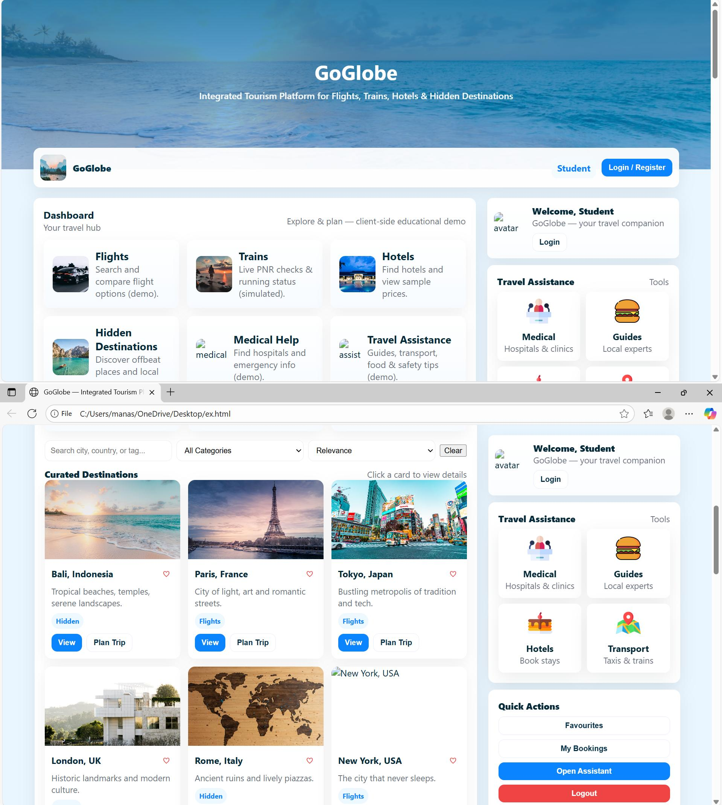
Screenshots of the app

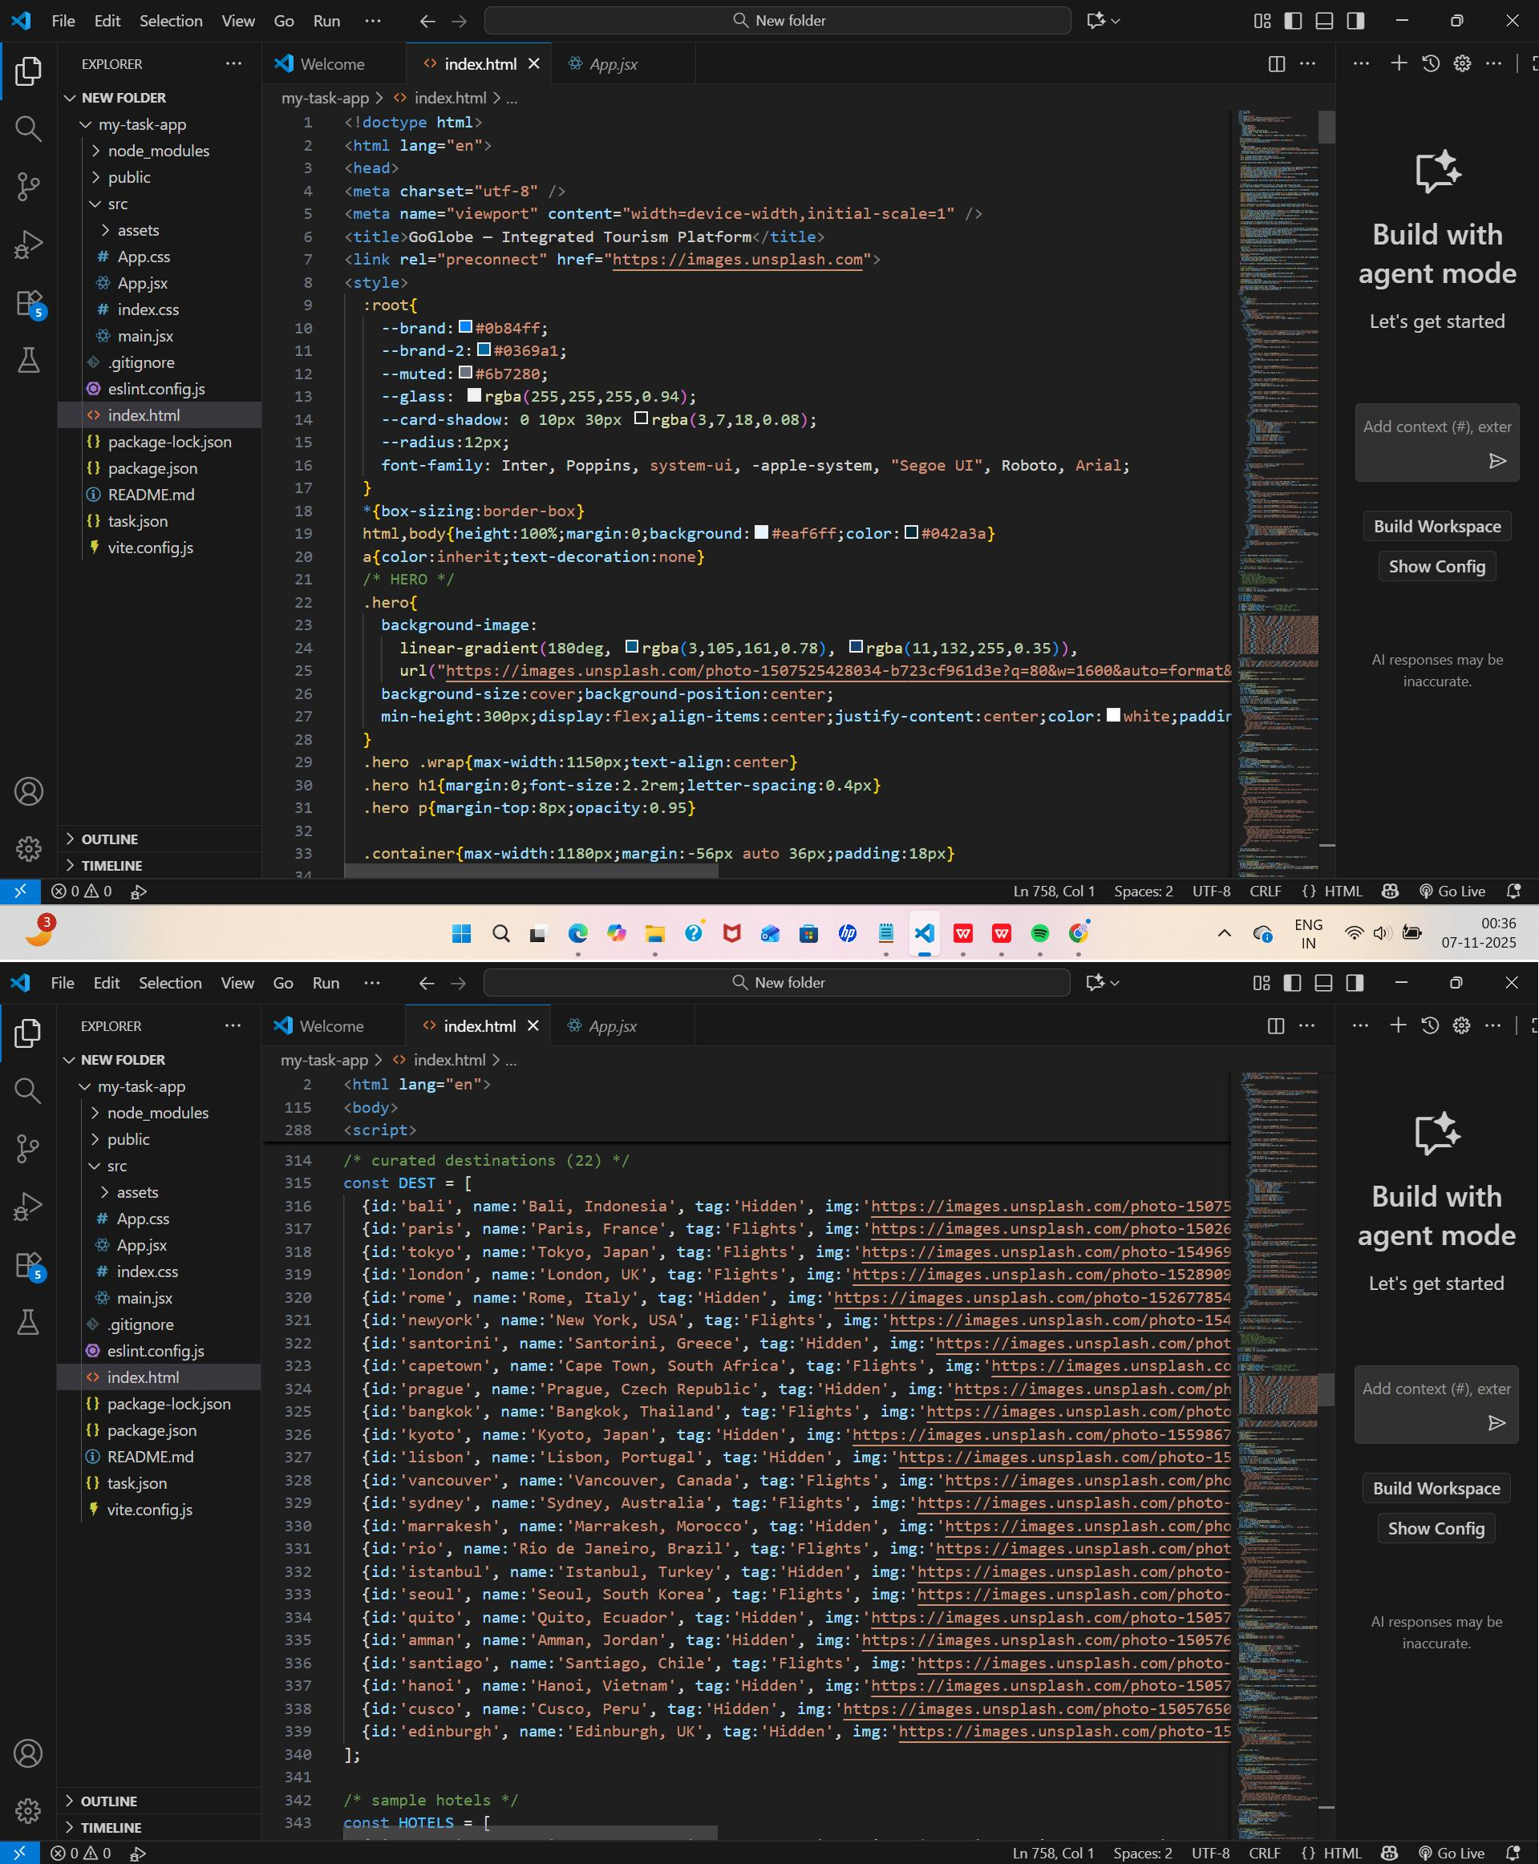
Sample code snippets

Installation/setup instructions

The GOglobe Integrated Tourism Platform is simple to install because it is built entirely using HTML, CSS, and JavaScript. It does not require any external frameworks or databases. The setup can be completed in just a few steps.

First, download or copy the complete GOglobe project folder to your local computer. If it is shared as a ZIP file, extract it using any standard extraction tool. Make sure all files especially index.html, style.css, and script.js (if included) are in the same folder.

Next, open the folder in a text editor like Visual Studio Code or Sublime Text to review or modify the code. To run the project, simply double-click on the index.html file or right-click and select “Open with Browser.” The website will open and function in any modern browser such as Google Chrome, Microsoft Edge, or Firefox.

No installations or dependencies are needed. The project is fully self-contained and works offline, making it ideal for classroom demonstrations and educational submissions.

User manual or guide

When you open the GOglobe platform, the homepage displays the main navigation bar with options like Login, Register, Destinations, and Travel Assistance. Users can begin by clicking the Login or Register buttons. A clean, half-page form will appear where users can enter their details to simulate login or registration.

Once logged in, users can explore Top Global Destinations, view beautiful travel images, and get information about each place. The Travel Assistance section offers quick options like medical help, hotel booking, and transportation support all designed for educational simulation.

Navigation through the platform is smooth, with buttons that automatically scroll to their respective sections. Alerts confirm actions such as successful login or registration. The entire experience demonstrates how an integrated tourism platform would look and behave in a real-world environment.

Geo Tag photos with guide


Review forms with guide signatures

